

Biuro prasowe better. gaming agency

[bettergamingagency.prowly.com](http://bettergamingagency.prowly.com)

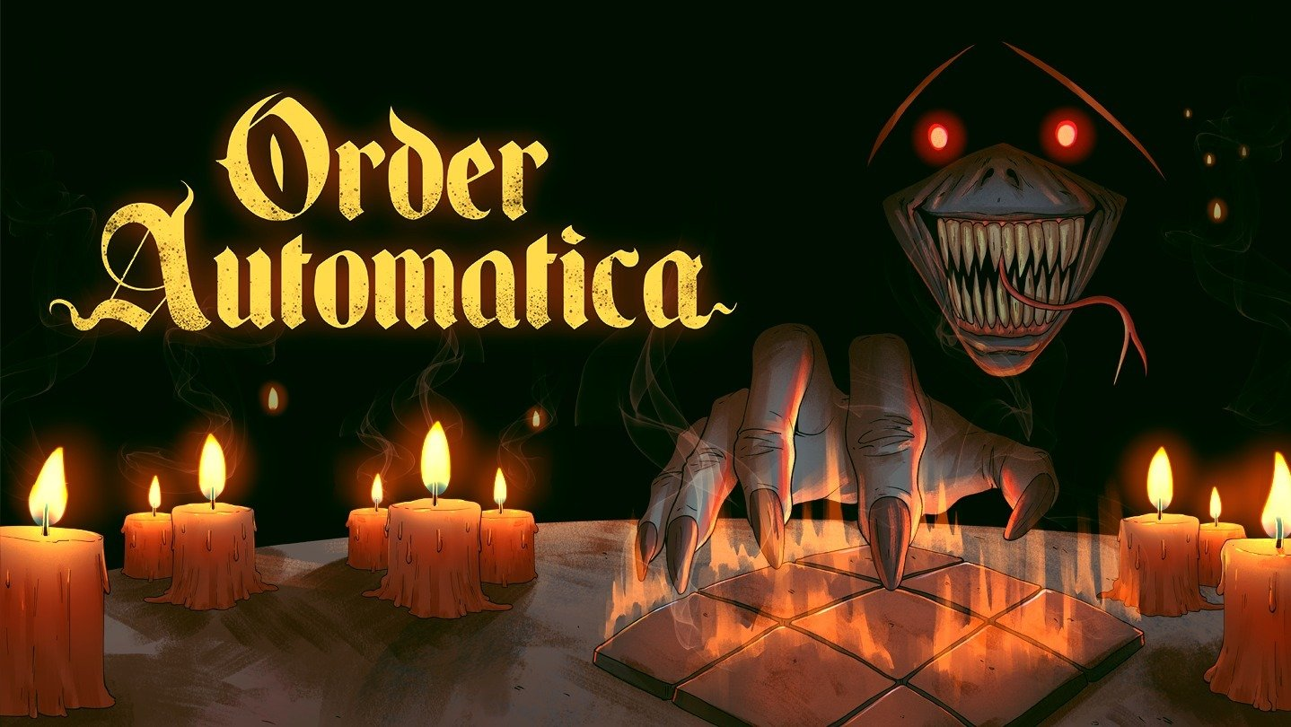

**Order Automatica – a mysterious game discovered in the heart of an ancient brotherhood**

Cold, thick walls and the underground chambers of an ancient order have concealed a mystery hidden from human eyes for ages – a game that, once uncovered, will leave nothing the same. New Beings is developing [**Order Automatica**](https://store.steampowered.com/app/2105840/Order_Automatica/), a dark roguelike auto-battler, scheduled for release by better. publishing in 2026. The developers have shared the latest trailer, presented during The MIX showcase, and anyone interested in exploring the mysterious brotherhood can [try the demo available on Steam until September 7](https://store.steampowered.com/app/2105840/Order_Automatica/). Will you survive long enough to complete the ritual before your last candle fades?

**Order Automatica – check out the latest trailer**

[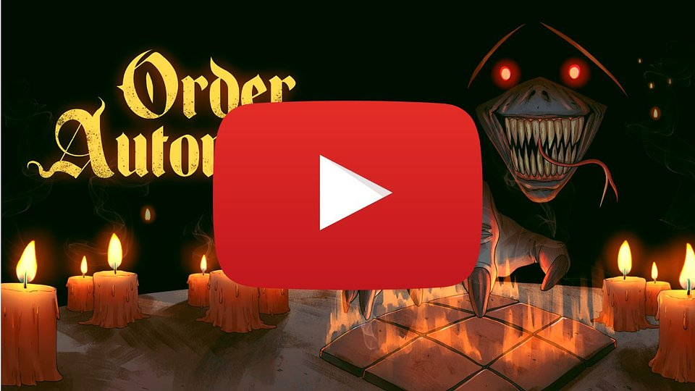](https://youtu.be/wq-eFKgT0Jc)

<https://youtu.be/wq-eFKgT0Jc>

Monsters from the darkest corners of the demon world are getting ready to fight each other in tactical battles. **Order Automatica** is a strategy game where combat unfolds automatically, and players’ main goal is to manage the battle through careful positioning of units. They need to consider each character’s strengths and weaknesses, the order of attacks, and make use of perks from skills and powerful artifacts. The goal is to create devastating combinations while exploiting gaps in the opponent’s defenses. The limited 3×3 grids for each side add a tactical layer, rewarding clever foresight and precise unit coordination.

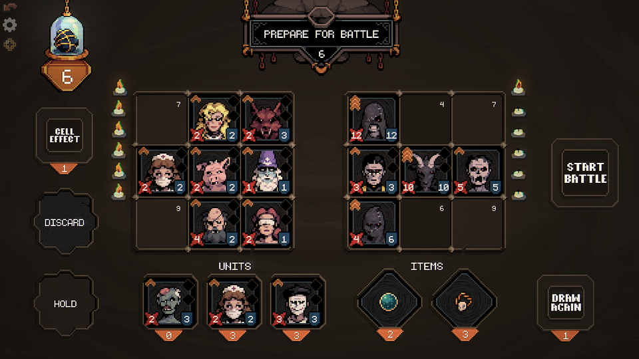

It all began with a seemingly innocent discovery by a scholar – the character whose shoes players step into. Amid the long-abandoned ruins, he uncovered a mysterious game and felt compelled to unravel its secrets. Slowly, its dark allure began to consume him, driving him ever closer to the edge of madness. The story traces a growing fascination and obsessive pull, revealing how an ancient game can quietly seize control of even the most rational mind.

In **Order Automatica**, victory doesn’t come from brute force, but from cleverness and foresight. As in many roguelikes, the core part of the experience is discovering synergies between characters and their abilities, experimenting with different builds, and… learning from failure. Each setback not only helps players understand their opponents better but also reveals new ways to bend the rules of this ancient game.

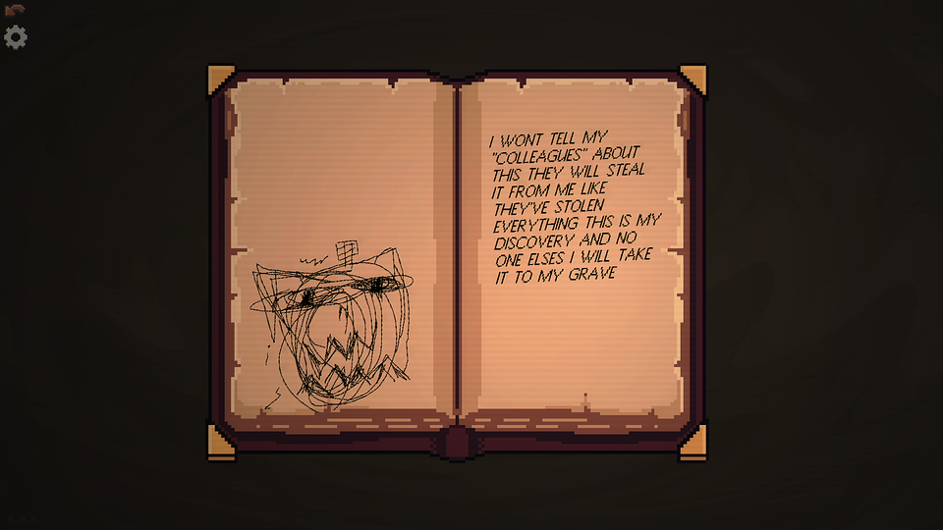

**Order Automatica – key features:**

🕯️ **Tactical puzzle** – Order Automatica will draw in anyone who enjoys tactical thinking and the unpredictable nature of roguelike games. Victory depends on mastering effective synergies, clever unit placement, and making the most of each creature’s strengths and weaknesses.

🕯️ **Shape your fate** – In this auto-battler, small battlefields and limited resources for recruiting units and buying upgrades challenge you to think several steps ahead, making every decision during the planning stage truly matter.

🕯️ **Secrets of the Order** – step into a dark tale of an ancient brotherhood and an occult ritual whose mysteries were never meant to be revealed.

🕯️ **Endless challenges** – diverse game modes ensure varied gameplay and almost limitless replayability.

🕯️ **Haunting pixel-art** – a unique visual style combined with hypnotic music creates an atmosphere that’s sure to give many players goosebumps.

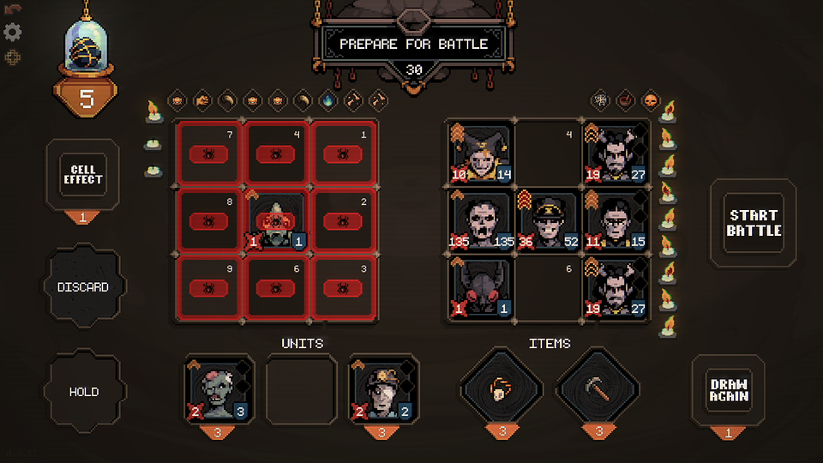

**better. publishing showreel**

[](https://youtu.be/GYgZxk9CugU)

<https://youtu.be/GYgZxk9CugU>

**Order Automatica** is scheduled for release in the second quarter of 2026 and will be [available on Steam](https://store.steampowered.com/app/2105840/Order_Automatica/). The game is developed by New Beings in collaboration with better. publishing, which officially announced the start of its publishing label during The MIX showcase. Until now, better. has primarily focused on supporting development studios with PR and marketing. In addition to Order Automatica, the company’s current portfolio includes: [Don't Wake the Beast](https://store.steampowered.com/app/3258580/Dont_Wake_the_Beast/) and [Void Dungeon](https://store.steampowered.com/app/3258590/Void_Dungeon/). For more information, visit the [official website](https://betterpublishing.pro/) and follow their social media profiles on [Facebook](https://www.facebook.com/betterpubpro), [X](https://x.com/betterpubpro) and [Instagram](https://www.instagram.com/betterpubpro).

The full press kit is available [HERE](https://drive.google.com/drive/u/1/folders/1aiCh7YHhhIU5b-ARRkQ0_6qht14RlVfv).

**About New Beings:**

[New Beings](https://newbeings.com/) is a solo development studio run by Mickey Sanchez, based in Portland, Oregon. Mickey gained industry experience by working on indie titles such as Big Hops, Wizard With a Gun, and The Wild at Heart. He has also shared his expertise in game development through teaching at the Pacific Northwest College of Art and Portland Community College. Mickey has released many small but captivating experimental games on itch.io with a focus on turn-based strategy and roguelikes. With help from several talented collaborators, he is now focused on his most ambitious project to date – Order Automatica, a pixel-art auto-battler set for release in 2026.

**About better. publishing:**

better. publishing draws on the extensive experience of better. gaming agency, which has provided PR and marketing support to publishers and developers of all sizes since 2018. Launching a publishing label was a natural next step, allowing the team to engage more deeply with projects and fully leverage the knowledge and expertise gained over the years. Every game tells a different story, follows a different journey, and meets a different need. The label believes in small teams, big ideas, and collaboration built on trust. It has been created for those who know how challenging game development can be – and how rewarding it is.

Currently, better. publishing is working on three titles: Don't Wake the Beast, Void Dungeon, and Order Automatica, all scheduled for release in 2026.