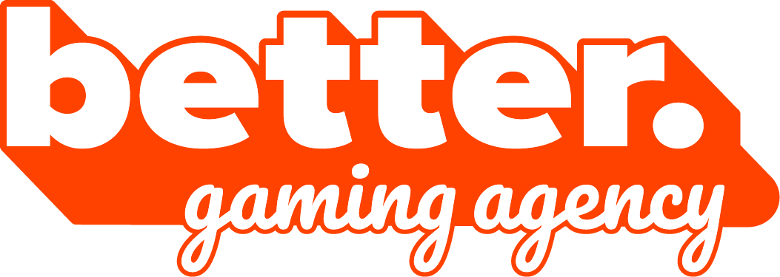

Biuro prasowe better. gaming agency

[bettergamingagency.prowly.com](http://bettergamingagency.prowly.com)

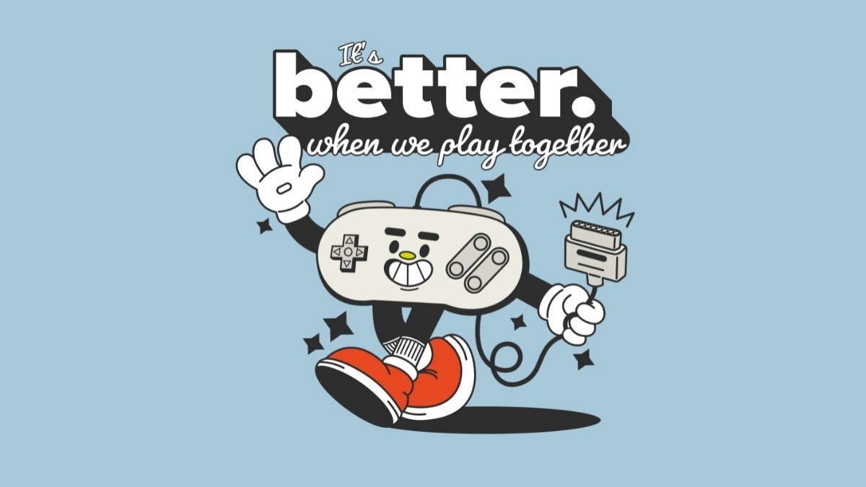

**better. publishing – the next chapter in the history of better. gaming agency and a new player on the publishing scene**

better. gaming agency has been supporting developers and publishers in PR and marketing activities since 2018. Over these seven years, brands such as Riot Games, Tencent, Techland, GOG, One More Level, and CI Games have placed their trust in the agency, creating together amazing campaigns and projects. With a wealth of experience gained, better. gaming agency is now stepping up their game by offering publishing services under better. publishing label.

With a line-up of three games, all scheduled for release in 2026, the new better. publishing label is stepping into the spotlight. The portfolio includes [Don't Wake the Beast](https://store.steampowered.com/app/3258580/Dont_Wake_the_Beast/?l=polish) by Artificial Disasters, [Void Dungeon](https://store.steampowered.com/app/3258590/Void_Dungeon/) from TRIK Soft, and [Order Automatica](https://store.steampowered.com/app/2105840/Order_Automatica/) from New Beings, all live and ready to be wishlisted on Steam. Thanks to the efforts of better. gaming agency’s PR and marketing teams, the titles have already been showcased at both physical and online events such as gamescom, PAX, Future Games Show, IGN Fan Fest, and The MIX. It was during these showcases that the idea for deeper collaboration first emerged.

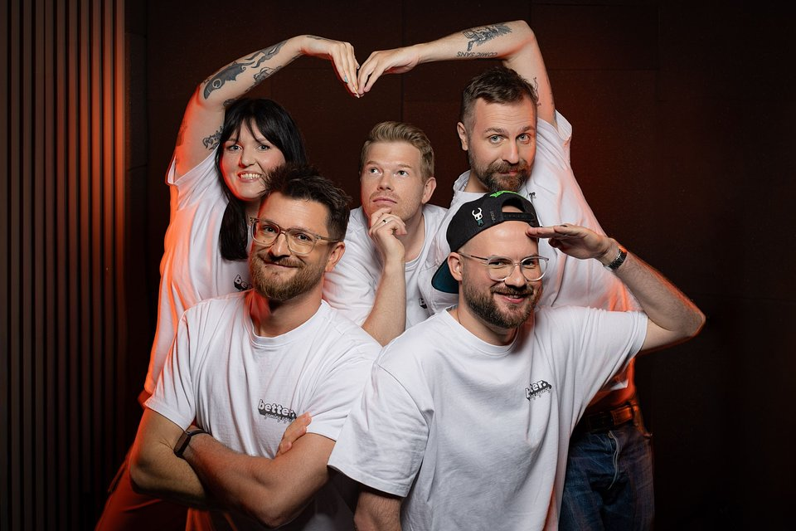

*Launching a publishing label felt like a natural next step for us. The years of experience supporting our clients have given us a deeper understanding of the industry. For the developers whose games we publish, we offer not only financial and production support, but also marketing and PR assistance, which has always been at the core of the agency’s services. Our partners can expect a comprehensive approach, ensuring maximum reach to media, online creators, and gaming communities. Our motto is: “It’s better. when we play together” and this is exactly the approach we believe in* **- said Kacper Bańbura, one of the founders of better.**

**better. publishing showreel**

**[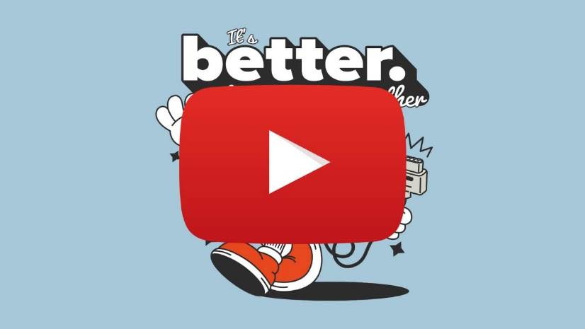](https://youtu.be/GYgZxk9CugU)**

<https://youtu.be/GYgZxk9CugU>

The changes in the company’s operations were accompanied by a complete rebranding, including a new logo. More details about the updated services can be found on the official website. The games published by better. publishing are:

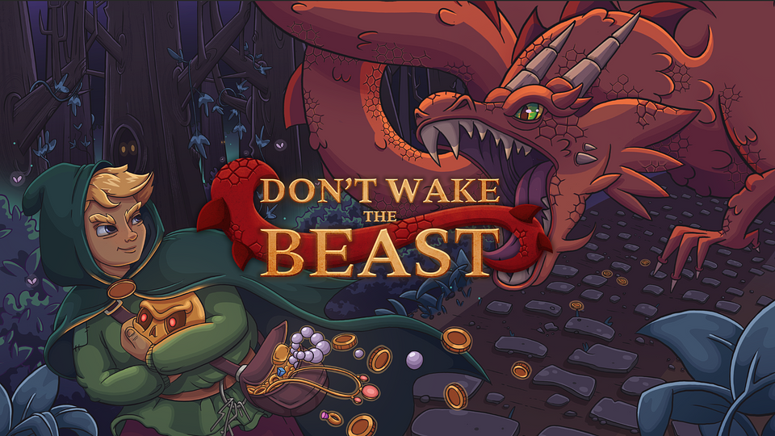

**Don't Wake the Beast from Artificial Disasters**

In this stealth-driven adventure, you play as a lone wanderer exploring dungeons, sneaking through dangerous corridors in search of treasure and valuables. Armed with nothing but your cunning, patience… and a grappling hook. Don’t Wake the Beast captures the essence of roguelikes – so even your failures bring you closer to success. Upgrading your gear will help you dodge deadly traps and outsmart monsters, but if the true master of the dungeon awakens, all you can do is run.

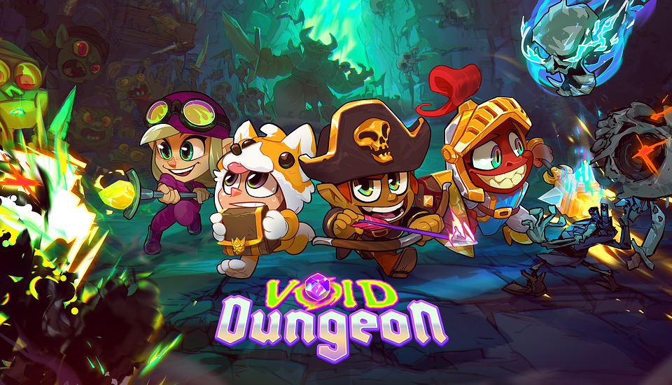

**Void Dungeon from TRIK Soft**

Dungeons, monsters, and loot – Void Dungeon ticks all hack-and-slash boxes. Inspired by the classics, the game plunges players into a world of magic and danger, where monsters lurking around every corner offer valuable XP. Fans of old-school adventures will feel right at home – think of a certain wanderer in a certain cathedral – and the addictive endgame content will keep you hunting for more treasures long after the main story ends.

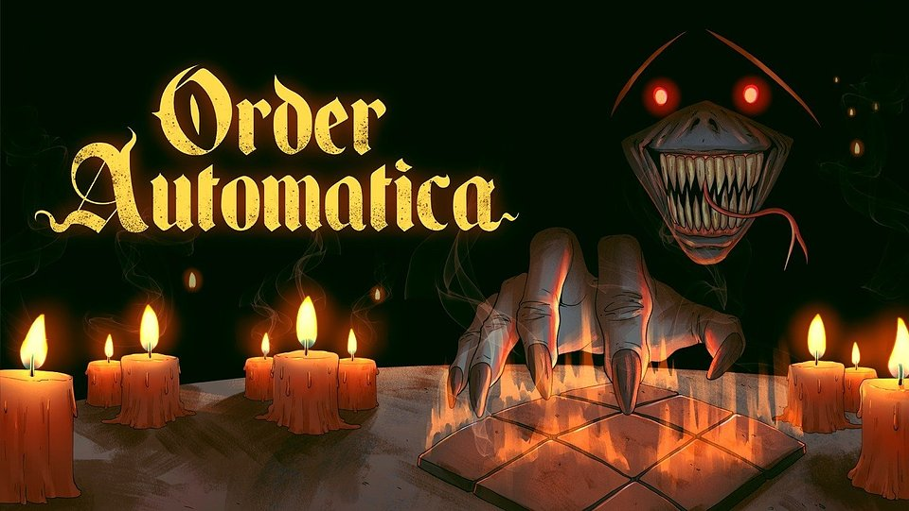

**Order Automatica from New Beings**

Order Automatica is an auto-battler where victory doesn’t come from brute force – it comes from cleverness and foresight. At the heart of the experience, like in many roguelikes, lies discovering synergies between characters and their abilities, experimenting with different builds, and… learning from failure. Every setback not only teaches you more about your opponents but also uncovers new ways to bend the rules of a game hidden for ages in the underground chambers of an ancient order.

All the games have their product pages on Steam, with releases scheduled for next year. To stay up to date with better. publishing projects, we encourage you to visit the [official website](http://betterpublishing.pro/) and follow the publisher’s social media channels – [Facebook](https://www.facebook.com/betterpubpro), [X](https://x.com/betterpubpro), [Instagram](https://www.instagram.com/betterpubpro), [TikTok](https://www.tiktok.com/@betterpubpro), and [YouTube](https://www.youtube.com/@betterpubpro).

The full press kit is available [HERE](https://drive.google.com/drive/u/1/folders/13W67pgYL6nQ0fM_tu_UCvDHRdWL9aqkG).

**About better. publishing:**

better. publishing draws on the extensive experience of better. gaming agency, which has provided PR and marketing support to publishers and developers of all sizes since 2018. Launching a publishing label was a natural next step, allowing the team to engage more deeply with projects and fully leverage the knowledge and expertise gained over the years. Every game tells a different story, follows a different journey, and meets a different need. The label believes in small teams, big ideas, and collaboration built on trust. It has been created for those who know how challenging game development can be – and how rewarding it is.

Currently, better. publishing is working on three titles: Don't Wake the Beast, Void Dungeon, and Order Automatica, all scheduled for release in 2026.