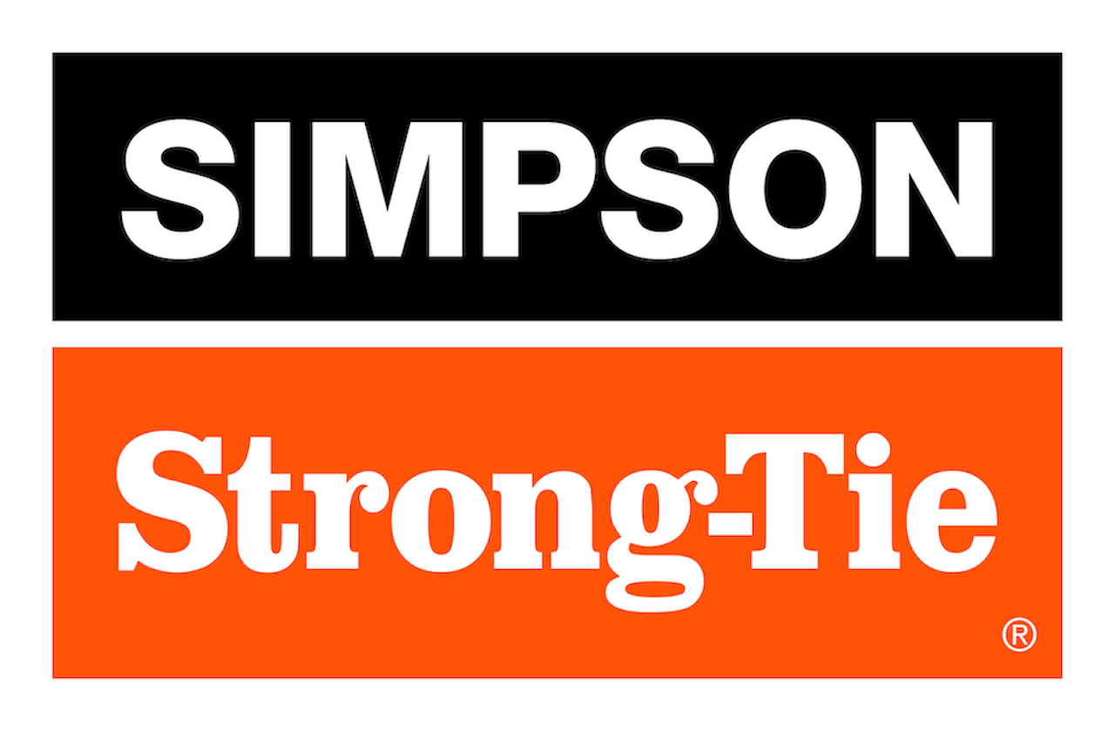

FOR IMMEDIATE RELEASE For More Information:
August 20, 2025 Jesse Russell
jrussell@strongtie.com
925-557-5324

PFPS™ Purlin Splice Connector From Simpson Strong-Tie Reduces Costs, Enhances Installation Efficiency for Post Frame Construction
Pleasanton, Calif. — Simpson Strong-Tie, the leader in engineered structural connectors and building solutions, has introduced the PFPS24 purlin splice connector for post frame construction. Designed to simplify roof purlin connections, the PFPS24 eliminates the need to offset and overlap purlins, keeping them in line along the entire length of a gable roof. The connector’s design enhances purlin and roof panel installation efficiency and improves fastener alignment; furthermore, it reduces material costs by allowing the use of shorter, more economical purlin stock.

With minimum and maximum fastener options, the PFPS24 purlin splice connector provides value engineering opportunities depending on load requirements; a minimum fastener pattern can reduce installed fasteners by up to four per connector, lowering labor costs without compromising compliance. Its unique design also allows connectors to be doubled up for increased capacity where needed.

In addition, by keeping purlins aligned, the connector eliminates staggered roof panel fasteners, reducing risk of misinstallation.

“The innovative design of the PFPS24 purlin splice connector enhances its versatility and simplifies installation,” said Randy Daudet, group product manager for Simpson Strong-Tie. “As a result, post frame construction is stronger, faster and more efficient.”

The PFPS24 purlin splice connector is fully tested to ensure strength, durability and peace of mind for specifiers and builders. It provides tested load values for both nail and screw fastening options.

To learn more, visit www.strongtie.com.

About Simpson Strong-Tie Company Inc.
Simpson Strong-Tie is the world leader in structural solutions — products and technology that help people design and build safer, stronger homes, buildings, and communities. As a pioneer in the building industry, we have an unmatched passion for problem solving through skillful engineering and thoughtful innovation. Our structural systems research and rigorous testing enable us to design code-listed, value-engineered solutions for a multitude of applications in wood, steel, and concrete structures. Our dedication to pursuing ever-better construction products and technology and to surrounding our customers with exceptional service and support has been core to our mission since 1956. For more information, visit strongtie.com and follow us on Facebook, Twitter, YouTube and LinkedIn.

###

