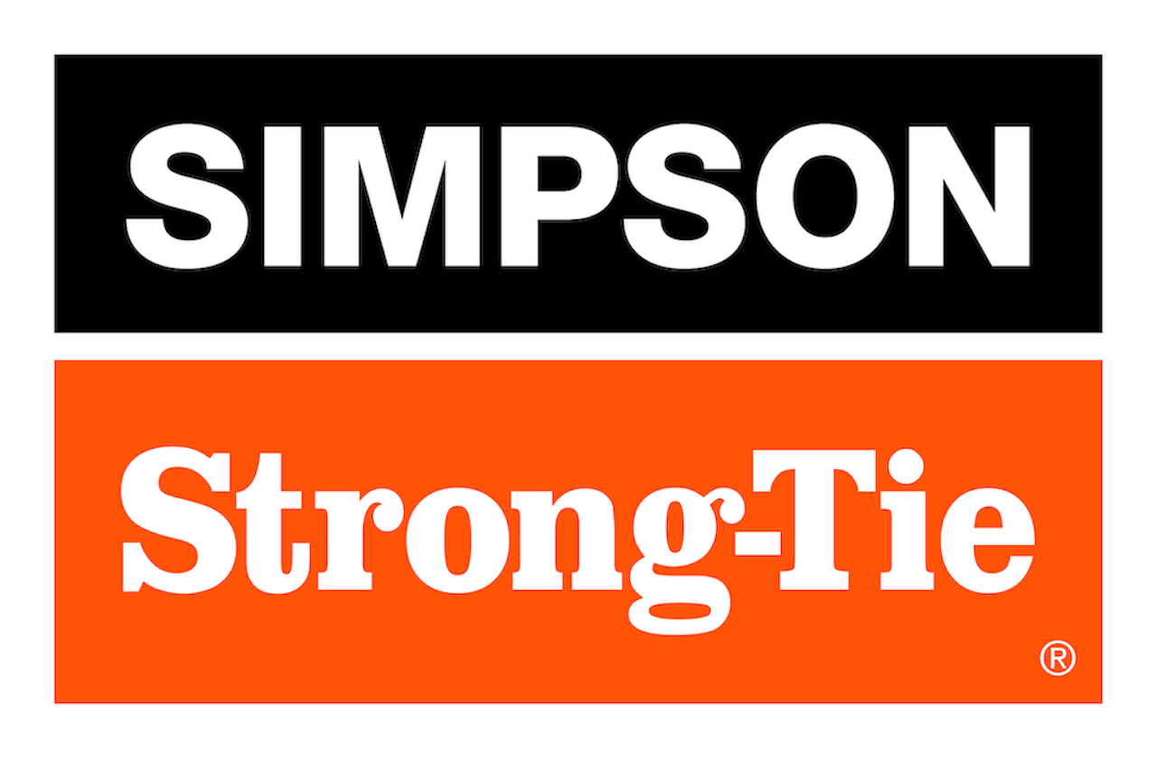

FOR IMMEDIATE RELEASE For More Information:
August 6, 2025 Jesse Russell
jrussell@strongtie.com
925-557-5324

Simpson Strong-Tie Launches MPSC™, an Innovative High-Capacity Connection for Mass Timber Structures

Pleasanton, Calif. — Simpson Strong-Tie, the leader in engineered structural connectors and building solutions, has introduced the MPSC™ mass timber point-supported column connection. By supporting mass timber floor panels while simultaneously transferring the download from the column above without crushing the floor, the MPSC unlocks the potential of post-and-plate mass timber buildings.

“Post-and-plate structures use the mass timber panels’ two-way span capabilities, eliminating the need for floor beams and girders,” said Michael Weinert, senior product manager for Simpson Strong-Tie. “These structures have reduced column grid spacing, optimized clear floor height, and simplified horizontal mechanical, electrical and plumbing routing. The MPSC column connection makes designing and installing such post-and-plate structures easier and more efficient.”

Thanks to its innovative design, the MPSC column connection’s top and bottom halves easily slot together onsite and connect in seconds with a single bolt, helping to minimize crane time. The connection has a high download capacity in five load ratings from 100 to 300 kips, and it allows column rocking to provide seismic deformation compatibility.

The MPSC column connection is configurable to accommodate a range of panel thicknesses and panel support area requirements. It allows for up to 1/4" of vertical adjustability using shim plates. In addition, the bolt holes can be used as a rigging attachment point for column lifting.

To learn more, visit www.strongtie.com.

About Simpson Strong-Tie Company Inc.
Simpson Strong-Tie is the world leader in structural solutions — products and technology that help people design and build safer, stronger homes, buildings, and communities. As a pioneer in the building industry, we have an unmatched passion for problem solving through skillful engineering and thoughtful innovation. Our structural systems research and rigorous testing enable us to design code-listed, value-engineered solutions for a multitude of applications in wood, steel, and concrete structures. Our dedication to pursuing ever-better construction products and technology and to surrounding our customers with exceptional service and support has been core to our mission since 1956. For more information, visit strongtie.com and follow us on Facebook, Twitter, YouTube and LinkedIn.

###

