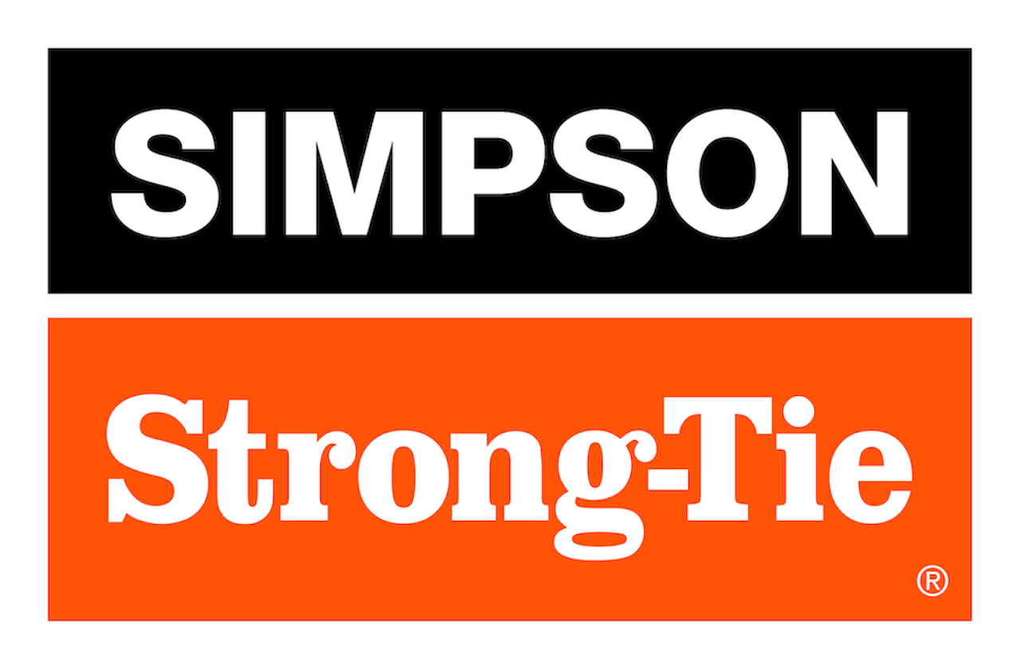

FOR IMMEDIATE RELEASE For More Information:
July 22, 2025 Jesse Russell
jrussell@strongtie.com
925-557-5324

Pergolas Made Easy: New Outdoor Accents® Sage System™ Connectors Allow DIYers to Build Outdoor Shade Structures Quickly

Pleasanton, Calif. — Simpson Strong-Tie, the leader in engineered structural connectors and building solutions, has launched the Sage System™ modular pergola kit, which allows DIYers to build stunning outdoor shade structures in a single afternoon.

The heart of the Sage System DIY pergola builder are the innovative open-top connectors that simplify installation: Simply drop or slide in 4x4 or 6x6 lumber and then fasten with color-matched Outdoor Accents® connector screws (included). The system includes corner connectors for joining posts to beams and middle-T connectors for mid-span support or multi-bay structures. Rounding out the line are post bases with outside flanges for easy installation on concrete using DIY-friendly Titen Turbo™ screw anchors (also included); a standoff tab inside the post bases helps prevent wood rot.

“The Sage System brings together strength, beauty and simplicity, making it easier than ever for homeowners to create durable shading structures that will enhance their outdoor living spaces,” said Bryan Wert, director of Connectors & Lateral Systems Product Development for Simpson Strong-Tie. “These connectors take the guesswork out of building a strong, beautiful pergola. There are no complicated corner cuts needed, just straight-cut lumber. You can build a complete pergola, start to finish, in the space of an afternoon.”

Once the structure is complete, homeowners can finish the look with a Sage System sunshade, available in 8' x 8' and 10' x 10' sizes in gray and tan colors.

Sage System connectors use ZMAX® galvanized steel for superior corrosion resistance and feature a sleek black powder coat for a beautiful finish.

Sage System connectors are part of the Simpson Strong-Tie® Outdoor Accents line of decorative hardware. To learn more, visit go.strongtie.com/sagesystem.

About Simpson Strong-Tie Company Inc.
Simpson Strong-Tie is the world leader in structural solutions — products and technology that help people design and build safer, stronger homes, buildings, and communities. As a pioneer in the building industry, we have an unmatched passion for problem solving through skillful engineering and thoughtful innovation. Our structural systems research and rigorous testing enable us to design code-listed, value-engineered solutions for a multitude of applications in wood, steel, and concrete structures. Our dedication to pursuing ever-better construction products and technology and to surrounding our customers with exceptional service and support has been core to our mission since 1956. For more information, visit strongtie.com and follow us on Facebook, Twitter, YouTube and LinkedIn.

###

