

Biuro prasowe better. gaming agency

[bettergamingagency.prowly.com](http://bettergamingagency.prowly.com)

Please notice that this press release is under embargo until July 24th at 7:00 PM CEST.

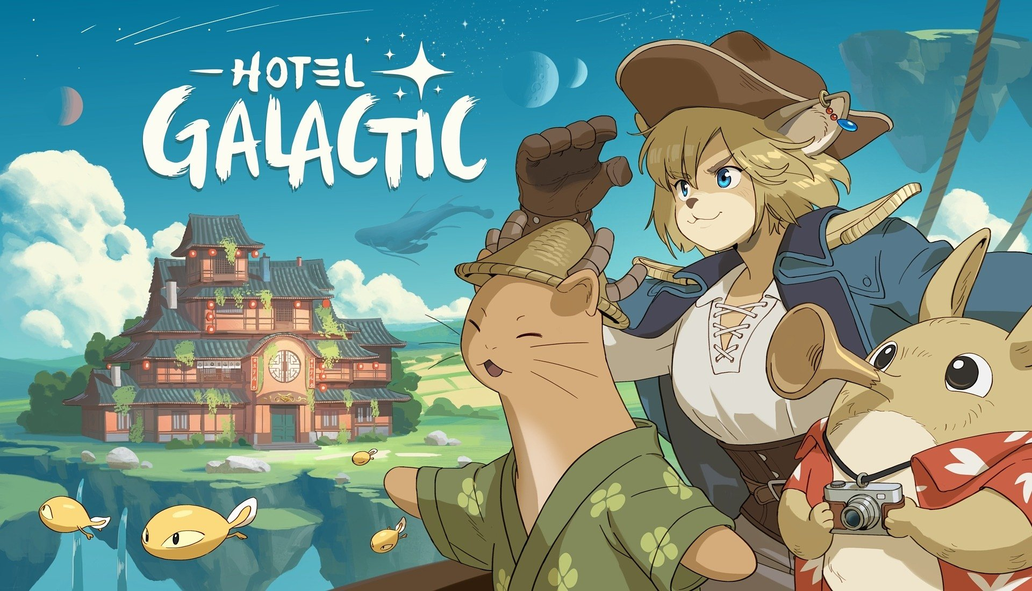

**Hotel Galactic is out now in Early Access!**

*Build and manage your own cozy tavern in this new stunning game from Ancient Forge!*

***Hotel Galactic*** *- an entrancing, story-rich and hand-painted simulation game about running your own dream tourist destination,* [*is now available in Early Access on Steam*](https://store.steampowered.com/app/2183670/Hotel_Galactic/)*.*

[Ancient Forge](https://ancientforgestudio.com/) - Polish indie studio known for well-received landlord simulator [The Tenants](https://store.steampowered.com/app/1009560/The_Tenants/) has released their new management game with an unusual, hand-painted style - [**Hotel Galactic**](https://store.steampowered.com/app/2183670/Hotel_Galactic/). Enjoy the fairytale about redemption, friendship and kindness in the story mode, or unleash your creative spirit with the sandbox mode. Watch the new Launch Trailer and learn about the future of **Hotel Galactic** with its post release roadmap.

**To celebrate, we’ve prepared a** [**special webcomic about Marietta and her origin story**](https://www.webtoons.com/en/canvas/hotel-galactic-the-wind-thief/the-wind-thief/viewer?title_no=1074810&episode_no=1)**, being a prequel to Hotel Galactic!**

Early Access Launch – Use modular building mechanics to construct sprawling, unconventional structures towering over the floating cosmic island. Optimize your hotel layout for smooth operations and an unforgettable guest experience. Strategically manage resources, develop your workforce, and adapt to the evolving demands of a growing colony.

**Key Features:**

🌌 **Build and decorate** rooms the way you want!

🌌 Take care of your **varied guests and staff**!

🌌 **Manage your workers, hire new ones and consider their traits** to elevate your hotel service.

🌌 **Prepare new meals and recipes** and let your guests taste something extraordinary.

🌌 **Gather materials to craft items** and expand your hotel!

🌌 **Experience a heartfelt story** about redemption, friendship, and the power of hospitality.

**Hotel Galactic - launch trailer**

[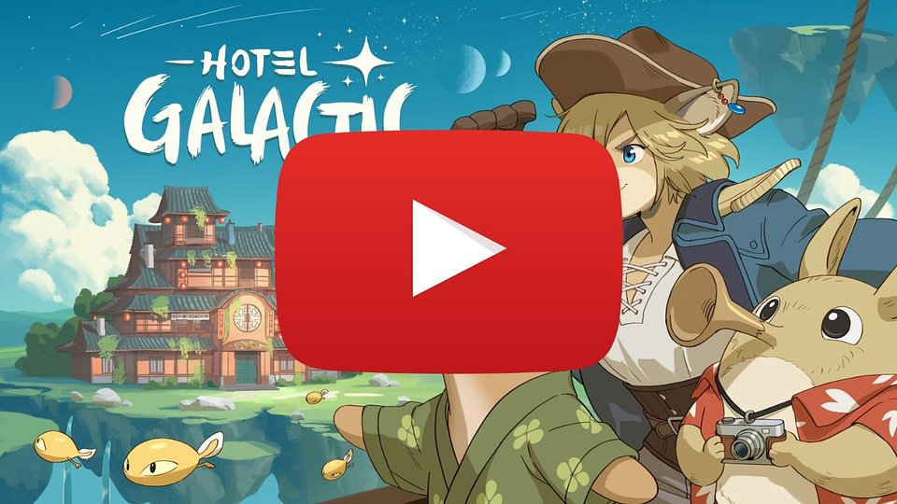](https://www.youtube.com/watch?v=DuSnaHsISn8)

<https://www.youtube.com/watch?v=DuSnaHsISn8>

The launch version of **Hotel Galactic** features the first act of the main story. Throughout this part you'll encounter 6 different alien races, many interesting NPCs introducing players to the rich lore of **Hotel Galactic**, and the first VIP visit. Aside from that, you can explore the Research Tree and adapt your hotel to your vision using new unlocked traits and blueprints.

In Early Access players can gather, craft, farm, cook custom recipes, process resources, tint walls and floors, equip workers with proper tools, mentor them, level up their skills, use research systems to uncover new optimization possibilities, and deal with the merchant (buying and selling items)”.

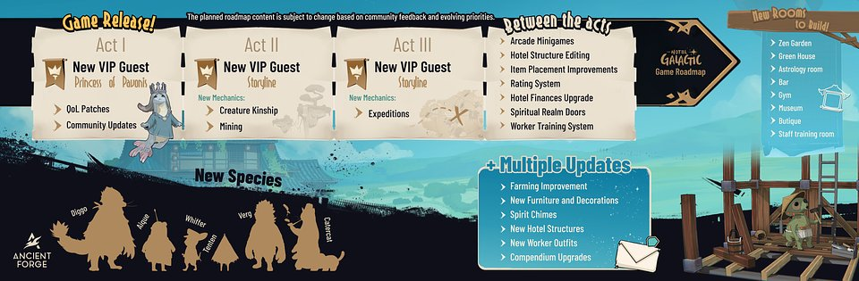

While there are 3 acts planned for this cozy game, Ancient Forge focus lies on the post launch Community Updates and first developing things demanded by the players. This approach worked well for The Tenants Early Access, and let creators and players work on the final shape of the game arm by arm, delivering the great gaming experience.

Among many things that are coming before 1.0 release, you can find 6 new species: Verg, Diggo, Aique, Catercat, Whiffer and Tenten. New VIP guests will also visit the hotel, bringing new quests and story progression. **Hotel Galactic** will also receive advanced Mining, Creature Kinship and Expeditions.With at least 8 new room types and multiple QoL improvements and content additions on the way, this early access will be fully-packed with interesting updates!

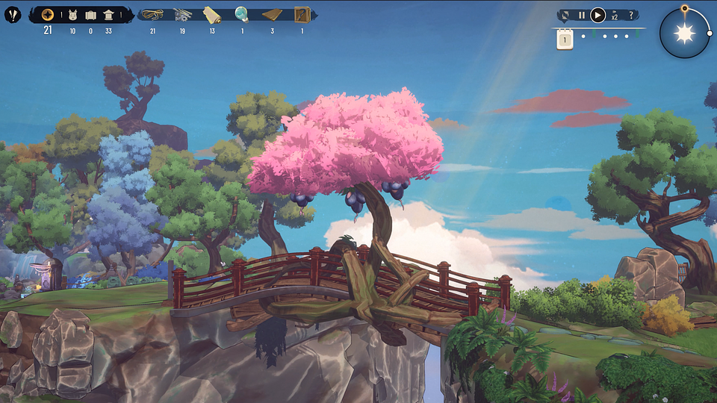

**Things to know before Hotel Galactic Early Access Release**

[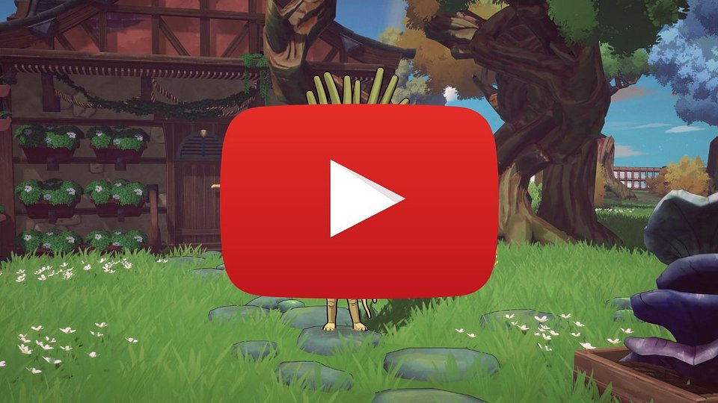](https://www.youtube.com/watch?v=5p5yrXtVBQs&feature=youtu.be)

https://www.youtube.com/watch?v=5p5yrXtVBQs&feature=youtu.be

**What is Hotel Galactic?**

**Hotel Galactic** is a charming management game where players transform a rundown cosmic hotel into a thriving space getaway. Inspired by classic anime aesthetics, the game seamlessly blends nostalgia with modern fairy-tale magic, featuring stunning hand-painted visuals, detailed animations, and a world bursting with warmth and adorable moments.

[Hotel Galactic is now available in Early Access on Steam](https://store.steampowered.com/app/2183670/Hotel_Galactic/) for 34.99 USD.

The full press kit is available [HERE](https://drive.google.com/drive/u/0/folders/1hOHDoqqf3ogfvmjSvafGle6Xi9LyQFfv).

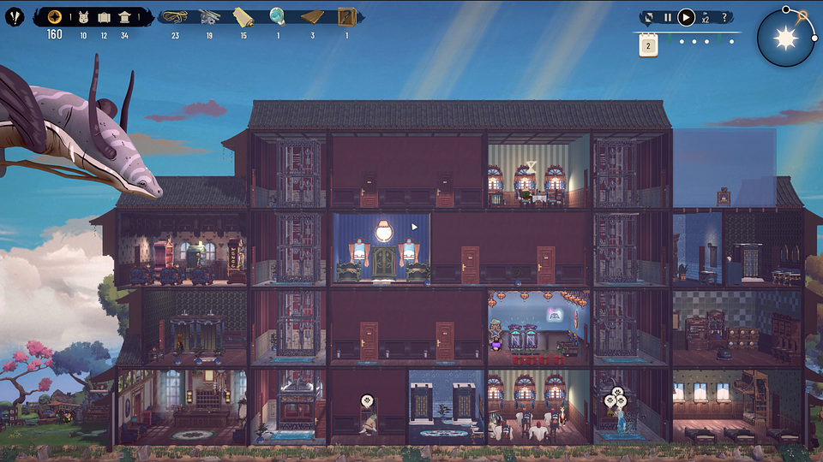

**About Ancient Forge:**

Ancient Forge is a Polish studio founded by Duszan Chaciej and Maksymilian Strzelecki, focused on creating and publishing games. The company rose to prominence with the release of The Tenants in 2022 – a well-received property management simulator that sold over 500,000 copies.

Since then, Ancient Forge has continued to push the boundaries of the management and simulation genres, working under a self-publishing model. The studio’s latest title, Hotel Galactic, has been wishlisted by over 220,000 players, and its demo on Steam has received more than 2,500 reviews – 96% of which are positive.

The team is made up of experienced and passionate developers united by their enthusiasm and drive to innovate in game design.