Hide from the heat and refresh your sounds
Summer sales expire this weekend from Native Instruments and iZotope

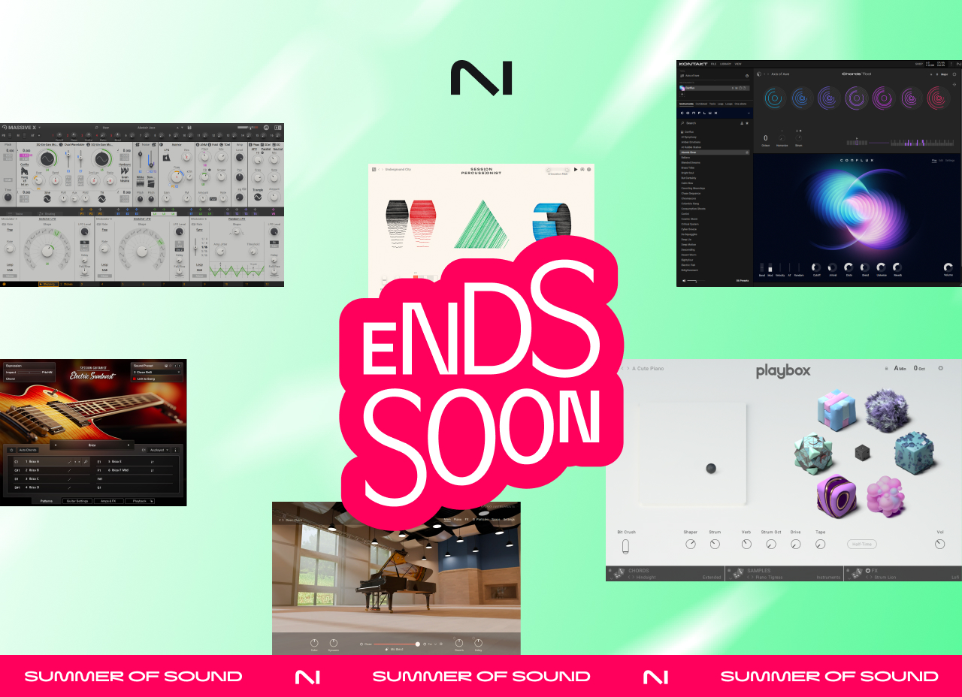
Berlin, June 26, 2025 – The sun is setting on some of the best music production deals of the summer. This weekend only you can still get plugins and instruments for every step of the creative journey from Native Instruments and iZotope before they’re gone on Monday, June 30.
Spark ideas and shape your sound with Native Instruments’ software and hardware, then polish, mix, and master to perfection with iZotope’s award-winning post-production tools.
Native Instruments’ Summer of Sound
- New MPC Expansions are here — Get the new Queensbridge Story and Rhythm Source MPC Expansions together for only $59 through June 30.
- Up to 50% off Komplete 15 — Access NI’s flagship collection of instruments, effects, and sounds up to 50% off.
- Choose your own — Build your own setup with major savings on individual instruments:
  - The Symphony Series Collection - $99 (90% off)
  - Jam Room Essentials - $99 ($560 value)
    - A limited-time collection of instruments and effects including drums, bass, guitar, organs, and piano with Guitar Rig 7 LE

iZotope Summer Sale

- Only a few days left to boost your mixes and masters: get your sound across the finish line with iZotope’s intelligent audio tools:
  - $200 off Music Production Suite 7.1 – iZotope’s full suite of intelligent mixing and mastering plugins.
  - Up to 40% off RX 11 – The industry’s gold standard for audio repair
  - 50% off Ozone 11 – The definitive mastering suite for professional-sounding tracks
  - 40% off Neutron 5 – An intelligent mixing suite built for precision and clarity
iZotope’s Summer Sale is the perfect moment to invest in tools that deliver next-level sound. Don’t miss the chance to finish your summer projects strong with a little help from iZotope.
Explore all the deals before they disappear on Monday, June 30.
- Native Instruments’ Summer of Sound
- iZotope Summer Sale

Media contact
press@native-instruments.com

About Native Instruments
For more than 25 years, Native Instruments has been at the center of musical innovation. The company has created communities, pushed technological boundaries, and opened new creative horizons for enthusiasts and professionals alike. Today, driven by their mission to make music creation more inclusive and accessible, the company's hardware, software across Native Instruments, iZotope and Plugin Alliance brands, provide fully-integrated solutions for musicians, producers, and DJs of all genres and levels of experience.

