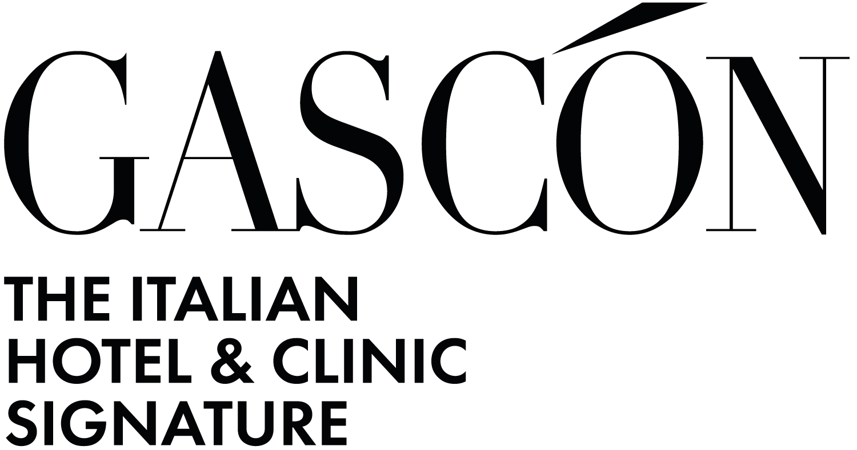

Valmont Clinic: a project for total wellness
The architecture studio Gascón Group was in charge of the design and renovation of Valmont Clinic spaces, a historic institution founded by Doctor Henri Auguste in Glion sur Montreux. Renowned as a reference in rehabilitation and wellness, the clinic represents a prestigious project for the studio, in which exclusivity and modernity harmoniously blend.
Specializing in luxury hotels and private clinics, the Gascón Group realized an interior intervention that combines functionality and aesthetics, creating sophisticated environments in which contemporary design enhances tradition, resulting in elegant, welcoming spaces that are perfectly balanced between innovation and heritage.
Designing spaces dedicated to personal care is a challenge that goes beyond mere functionality: it means creating environments that promote physical and mental well-being, transforming the very perception of rehabilitation.
The Gascón Group studio tackles this challenge with an approach that combines design, comfort and emotion, creating places that are not just clinics, but become spaces of total well-being. The goal is to eliminate the cold and impersonal aspect typical of health care facilities, replacing it with elegant, welcoming environments with refined aesthetics, inspired by the atmosphere of a five-star hotel.
Each project is designed to encourage recovery through a multisensory experience: from the natural light that envelops spaces, to the warm and tactile materials, to the harmonious arrangement of the furniture. Treatment should not just be a medical journey, but a global wellness experience, where the patient feels welcomed, protected and stimulated by an environment that conveys serenity and exclusivity.
Wellness through design: spaces that heal. Suite rooms.
The design of the suite rooms by Gascón Group has been conceived to ensure maximum flexibility in the use of spaces by adapting them to the needs of the patient himself and family members. The rooms and suites can thus be flexible in terms of size depending on who is accompanying the guest, guaranteeing comfort and privacy.
The design of the suites covers 1,000 square meters arranged on a single floor and is distinguished by its configuration, following a “cluster” model.
This design concept is expecting to have a series of rooms that, depending on the need, can be interconnected and thus increase in size so as to give the possibility of reaching 300 square meters of totally private space for the patient, offering an exclusive and personalized care and recovery experience.
The suites are designed to have a sleeping area, a living area, and a dining area. The design is the result of serenity-generating design because of the choice of warm materials and attention to aesthetic and functional comfort. The headboard of the bed creates an aesthetic impact while at the same time having all the essential equipment to provide full recovery care, such as oxygen and space for medication, which thanks to a wooden panel are hidden and not visible.
The materials used are of the highest quality: the floor is made of natural Hungarian herringbone oak parquet with 45-degree angles, the tables for the dining areas are made of fine marble, adorned with vases housing fresh, fragrant flowers, and the sofas in the living areas are upholstered in leather and herringbone cotton for a touch of color and sophistication.
Natural light is playing a key role in the design due to the presence of large windows that offer views of the lake. The suite rooms are thus naturally lit contributing to a feeling of well-being in strong connection with nature outside. The lighting present is soft with downward directed soft lights that blend with adjustable spotlights, creating a play of light crossings that give warmth to the environment.
Acoustics have been carefully defined to ensure maximum insulation between rooms separated by sliding doors.

Decorative details are carefully chosen to enhance the well-being of the environment by combining functionality and beauty to stimulate rest and recuperation. The choice of materials is also designed with special attention to functionality to encourage easy and quick daily cleaning without sacrificing beauty and elegance.
The catering areas and the outdoor terrace
The Gascón Group studio was in charge of the catering part of the Valmont Clinic. There were two areas of intervention: the workspaces, such as the kitchen, and the catering areas for guests.
The kitchen intervention was developed at the request of the client to transform the space into a place dedicated to the training of Swiss Medical Network Group chefs. The Gascón Group studio redesigned a more functional and innovative environment, providing for a significant expansion of the area, with a reorganization of the kitchen on two distinct levels. The lower level is dedicated to the technical room and the upper level organized according to dish preparation. This division was designed to optimize workflows and ensure effective management of training processes.
In the design phase, paths for waiters and chefs, different for outgoing preparations from the kitchen and withdrawn dishes, were identified in order to optimize logistics and ensure maximum safety and operational efficiency.
In order to ensure that the kitchen remains cutting edge over time, the traditional kitchen hoods were replaced with an innovative suction ceiling, a technologically advanced solution to improve the ergonomics of the working environment.

The guest area, on the other hand, includes a bar counter that has been strategically placed between the flow in and out of the kitchen, featuring a custom wine cellar flush with the surrounding paneling. The vertical inlaid lines of the paneling recall the historic style, reinterpreted with a modern twist, creating an elegant and sophisticated contrast. Everything is made of natural materials; the countertop is made of fine white Calacatta marble, characterized by veins tending to yellow and gray. A boiserie perimeter to the bar area marks a harmonious link with the suspended ceiling, giving the environment a sense of continuity and cohesion.
The restaurant area is designed to create an intimate and cozy atmosphere with a lighting system featuring warm lights and lamps placed on the tables, which gently emerge thanks to the deep, dark background of the furniture. The dark-toned atmosphere is designed as a frame that enhances the breathtaking view of the lake.
The Valmont Clinic also has a terrace that has been furnished with eco-friendly wood-effect material, which gives color and uniformity to the environment. The color choice of furniture softens the reflection of the sun, ensuring comfort always of the day.
The swimming pool and spa for a complete well-being
Gascón Group studio's intervention in the wellness area enhanced the pool area with special attention to the study of the guest's pathways for smooth enjoyment, with the addition of a new section dedicated to the spa in the beauty center, to offer the guest a complete and refined wellness experience. In terms of lighting, two main light sources have been adopted: spot light, which illuminates the spaces, and soft perimeter light, positioned poolside, designed not to disturb the guest while they are in the water, creating a gentle and tranquil atmosphere that promotes relaxation.
Gascón Group studio's entire design for the Valmont Clinic follows a clean, minimalist architectural style and design, in which each element is designed to harmonize with the others and create a welcoming space. The simplicity of the forms and sobriety of the furnishings lend a timeless elegance, while the functionality of the spaces ensures that every service is easily accessible and usable. Thanks to this fusion, the Valmont Clinic continues to be a guide in the luxury rehabilitation industry.

GASCÓN GROUP SA – ARCHITECTURE STUDIO
Main headquarters:
Via Carlo Frasca, 3 – Lucano, Svizzera
+41 (0) 91 910 97 50
info@gascon.ch
www.gascon.ch

Montreux headquarters:
Avenue des Alpes, 72 – Montreux, Svizzera
+41 (0) 21 961 10 66
info@gascon.ch
www.gascon.ch

Como headquarters:
Via Rodari, 9 – Como, Italia
+39 031 81 23 703
info@gascon.ch
www.gascon.ch
For press inquiries and personalized interviews:

OGS PR & COMMUNICATION
Via Koristka 3, Milano - Italia
+39 023450610
info@ogscommunication.com
www.ogscommunication.com
press.ogscommunication.com

