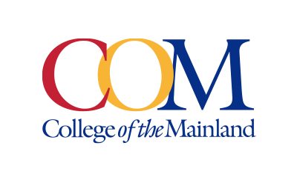
Marketing and Public Affairs Department
Contact: Jose Salazar, Communications Specialist, (409) 933-8923 or jsalazar18@com.edu
Written by: Jose Salazar, Communications Specialist

NEWS RELEASE
February 7, 2025

Radiating Compassion Earns COM Student UTMB Recognition

(Texas City, Texas) – First-year College of the Mainland radiologic technology (rad tech) student Robel Araya was recently recognized by the University of Texas Medical Branch (UTMB) Professionalism Committee for his exceptional efforts in the workplace. What started as a simple conversation led to a profound impact on a patient visiting UTMB Clear Lake, where Robel works as a rad tech assistant.
During his shift at UTMB, Robel noticed a patient had been waiting for an extended time to receive their magnetic resonance imaging (MRI) scan. Seeing that the patient was alone, he decided to accompany them and start a conversation.
“We talked about football and lighthearted stuff; she asked me about school,” Robel shared. “She shared with me how she has a kid, and I was telling her how they should go into rad tech.”

Their conversation lasted about an hour, continuing past the MRI scan and onto the patient's way out. Robel emphasized that he wasn’t doing anything out of the ordinary–just being himself. “You want to treat everybody the same and give everybody the same type of treatment you would want.”
The time and attention Robel gave to the patient had a lasting impact, prompting them to submit a review praising his exceptional patient care and interpersonal skills. The review gained the attention of not only his supervisors but also the president of UTMB, leading to his recognition with the professionalism award.
“It's a small thing in the grand scheme of things; I want to keep this going,” Robel said.

His compassion and dedication reflect the commitment College of the Mainland students have toward the healthcare field. This award is just the beginning of many more to come for Robel in his career.
###

Photo: Robel Araya stands with his professionalism award in the College of the Mainland radiologic technology classroom.

Contact: Jose Salazar, Communications Specialist, (409) 933-8923 or jsalazar18@com.edu

College of the Mainland is a learning-centered, comprehensive community college dedicated to student success and the intellectual and economic prosperity of the diverse communities we serve. Taxing districts include the independent school districts of Dickinson, Hitchcock, Santa Fe and Texas City/La Marque. Its service area includes League City, Friendswood, Kemah, Bacliff and San Leon.

