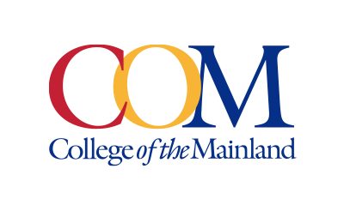
Marketing and Public Affairs Department
Contact: Jose Salazar, Communications Specialist, (409) 933-8923 or jsalazar18@com.edu
Written by: Jose Salazar, Communications Specialist

NEWS RELEASE
February 4, 2025

COM Original Theatre Production Earns Spotlight at College Theatre Festival

(Texas City, Texas) — An original production, “FUNNY BONED -or- How I Learned to SCHTICK the Landing”, written by College of the Mainland (COM) Theatre Program Director H. Russ Brown, has been selected to showcase as an invited production at the Region 6 Kennedy Center American College Theatre Festival (KCACTF) taking place February 23-27 in Abilene, Texas.
“It’s all thanks to my amazing students,” said Brown. “It shows that COM Theatre is a step above.”
The cast, crew and set of COM’s production FUNNY BONED will travel to Abilene, Texas to showcase their skills and production for a panel of judges representing the national KCACTF with the hope of earning national recognition. When not performing, the students will represent COM in an array of acting and musical scholarship competitions, joining hundreds of other theatre majors from two-year and four-year colleges across the Region 6 (Texas, Arkansas, Louisiana, New Mexico and Oklahoma). Though COM students attend the Region 6 KCACTF every year to compete, this is only the second time COM has been selected as an invited production.
“It’s a real validation of the training the students are receiving here,” Brown added.
First-year COM student and theatre major Ryan McClelland plays Duppy O’Gale in FUNNY BONED. Duppy, a former vaudeville performer turned ghost, haunts a Broadway theatre and lends his supernatural aid to Leslie the new emergency replacement assistant stage manager. McClelland shared his excitement about bringing this unique character to life.
“Getting the honor to originate a character like this is just unimaginable,” McClelland said. He expressed gratitude for the role and for Director H. Russ Brown’s guidance, which has helped him “come out of his shell.” “It has been an amazing journey, and I can’t wait to continue learning.”
Since 1972, COM Theatre has presented more than 300 productions, including children’s theatre, concerts and workshops, with an attendance of over a quarter of a million people. The program has been recognized as a leading theatre program, setting high production standards and developing one of the country’s most innovative training programs.
###

Photo: Full cast of FUNNY BONED -or- How I Learned to SCHTICK the Landing on set.
Photo Credit: Pin Lim / Forest Photography

Contact: Jose Salazar, Communications Specialist, (409) 933-8923 or jsalazar18@com.edu

College of the Mainland is a learning-centered, comprehensive community college dedicated to student success and the intellectual and economic prosperity of the diverse communities we serve. Taxing districts include the independent school districts of Dickinson, Hitchcock, Santa Fe and Texas City/La Marque. Its service area includes League City, Friendswood, Kemah, Bacliff and San Leon.

