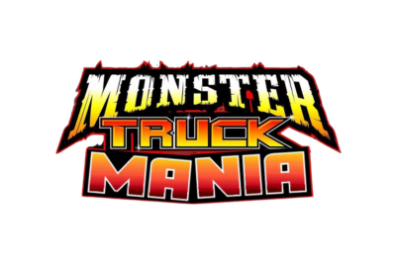

**FOR IMMEDIATE RELEASE  
MONSTER TRUCK MANIA RUMBLES INTO FARGO — SATURDAY, SEPTEMBER 20, 2025**

**Fargo, ND** – Get ready for pedal-to-the-metal adrenaline as **Monster Truck Mania** revs into town on **Saturday, September 20, 2025**, with a special matinee show full of high-flying, tire‑smashing action! Held at the renowned **Red River Valley Fairgrounds** (1805 Main Ave W, West Fargo, ND), this family-friendly monster truck extravaganza promises thrills, chills, and unforgettable automotive chaos.

**EVENT OVERVIEW**

* **Matinee Show** kicks off at **2:00 p.m. CDT**
* **VIP Pit Party** (exclusive access to meet drivers & trucks): 12:00–1:30 p.m.  
  + VIP gates open at 12:00 p.m., and General Admission gates open at 12:30 p.m.
* The main event runs approximately 90 minutes, featuring monster trucks crushing cars, performing jaw-dropping jumps, and engaging in fierce head‑to‑head battles.

**WHY YOU CAN’T MISS IT**

* **Pre-Show Pit Party** – Get a chance to meet the drivers! Get up close to huge monster trucks & see the track up close where all the Monster Truck Mania happens + kids can enjoy the BOUNCE HOUSE in the Kids' FUN ZONE!
* **Family Entertainment** – Kids can be part of the monster truck show, too! Bring your Powerwheel and reserve your spot early! Kids ages 3 to 9 years old.
* **Ride in a REAL Monster Truck** – Sergeant Smash will be selling rides throughout the big show!
* **Quad Wars** – See the pro's in wheel to wheel racing action on our fast track for a big cash purse & bragging rights!

**LOCATION & PARKING**

* Address: Red River Valley Fairgrounds, 1805 Main Ave W, West Fargo, ND 58078 [\](https://event.attendstar.com/event/show/monster-truck-mania-fargo-nd?utm_source=chatgpt.com)
* Convenient parking and concessions will be available on-site.

**ABOUT MONSTER TRUCK MANIA**

Driven by heart-pounding performance and raw power, Monster Truck Mania is a showcase of the toughest, baddest trucks on four massive wheels. With expert drivers and outrageous stunts, the show delivers non-stop entertainment, making it a beacon for motorsports lovers across the region.

**PRESS & MEDIA INFO**

Media wishing to cover the event or request press credentials should contact Ron Woodbridge: **(480) 881‑2375**.

**FOLLOW & SHARE**

Stay up-to-date and join the conversation: look for **Monster Truck Mania** on Facebook.

**Don’t miss this chance to experience the exhilarating world of monster trucks live in Fargo this fall—September 20th at the Red River Valley Fairgrounds. Spectators of all ages will roar with excitement!**

**FOR MEDIA INQUIRIES:**Ron Woodbridge  
 Phone: (480) 881‑2375