Caption 1  A vibrant start at the Sarawak Pavilion, WTM London 2025!  Crowds gathered to experience a glimpse of Borneo through traditional music, dance, and cultural showcases — proudly representing Sarawak, the Gateway to Borneo. | 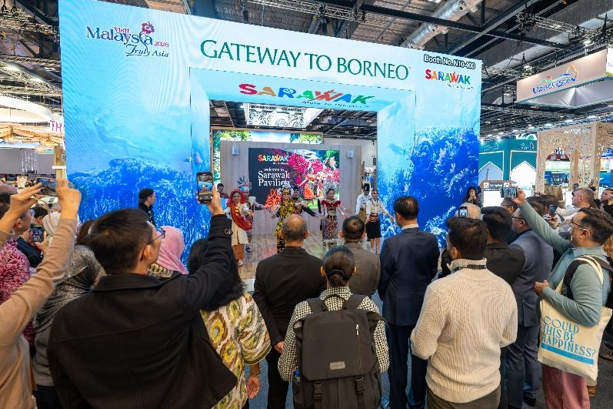
Caption 2:  YB Dato Sri Abdul Karim Rahman Hamzah, Minister of Tourism, Creative Industry and Performing Arts Sarawak, showing The Wonders of Malaysian Borneo UNESCO Sites & Geopark digital e-brochures on the iPad to Mr. Mohiuddin Ghazali, Deputy High Commissioner of Malaysia (left), YB Datuk Seri Sebastian Ting Chiew Yew, Deputy Minister for Tourism, and YB Dato Dennis Ngau, Chairman of Sarawak Tourism Board (right) at the launching of Gateway to Borneo, Sarawak Pavilion during WTM London 2025. | 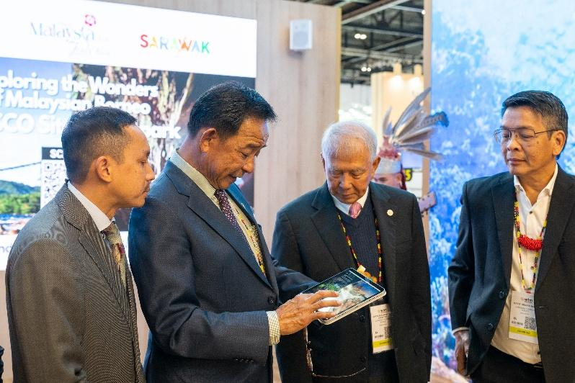
Caption 3 :  YB Dato Sri Abdul Karim Rahman Hamzah, Minister for Tourism, Creative Industry and Performing Arts Sarawak, together with YB Datuk Seri Sebastian Ting Chiew Yew, Deputy Minister for Tourism, YB Dato Dennis Ngau, Chairman of Sarawak Tourism Board, and Mr. Mohiuddin Ghazali, Deputy High Commissioner of Malaysia to the United Kingdom, joined by the Sarawak delegation and cultural performers at the Sarawak Pavilion (Booth N10-400) during World Travel Market (WTM) London 2025.  The pavilion showcases Sarawak as the “Gateway to Borneo”, highlighting its rich culture, nature, and adventure offerings under the Visit Malaysia Year 2026 campaign. | 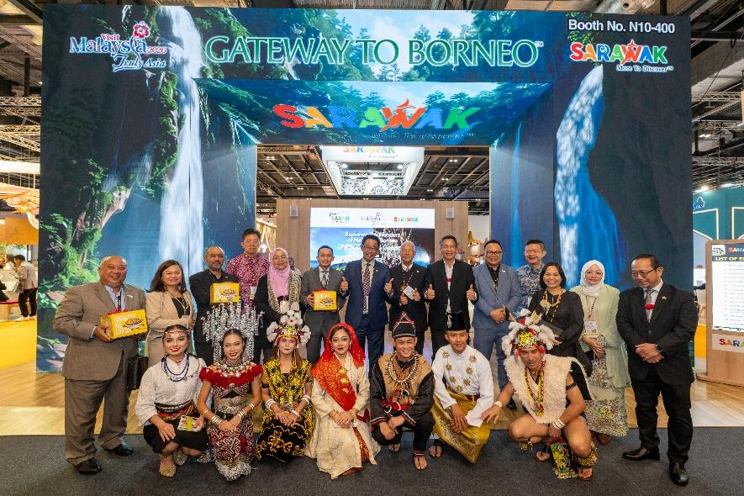
Caption 4 :  YB Dato Sri Abdul Karim Rahman Hamzah, Minister for Tourism, Creative Industry and Performing Arts Sarawak, showcasing “The Wonders of Malaysian Borneo – UNESCO Sites & Geopark” digital e-brochure together with Mr. Mohiuddin Ghazali, Deputy High Commissioner of Malaysia to the United Kingdom, (Left) the Sarawak delegates, and Mr. Julinus Jeffery Jimit, Chief Executive Officer of Sabah Tourism Board (Right) at the Sarawak Pavilion, WTM London 2025.. | 