[To be distributed on June 5, 2026, at 4 PM PT]
Press Release
Bloober Team and Lionsgate Reveal SAW: GENESIS,
A New Asymmetrical Multiplayer Horror Game That Expands
The Lore of the SAW Universe
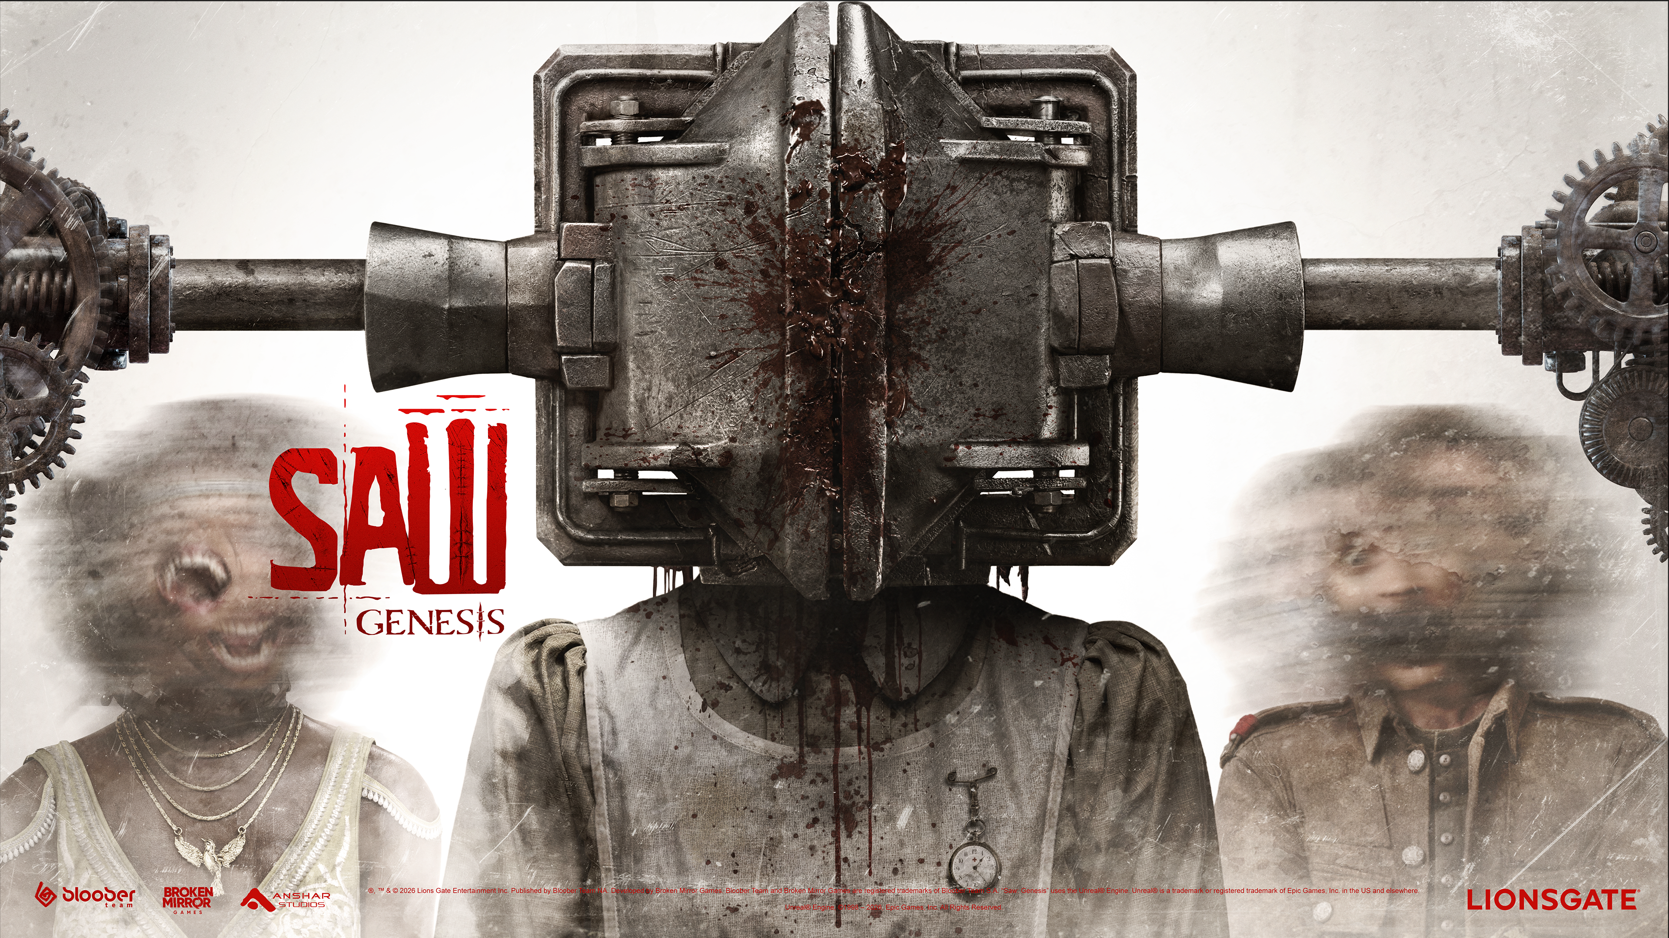5 June 2026, Cracow, Poland - Today at Summer Game Fest, Lionsgate, in collaboration with Bloober Team and its co-development label Broken Mirror Games, together with Anshar Studios, officially unveiled SAW: GENESIS - a twisted new asymmetrical multiplayer horror game featuring a storyline that precedes the events of the iconic SAW films and influences Jigsaw and his elaborate psychological games. Building on the success of the Blair Witch video game, the critically acclaimed horror developers have once again teamed up with Lionsgate, leveraging Bloober Team’s expertise in crafting immersive horror experiences, while expanding the lore of the SAW universe and preserving the psychological intensity that defines the franchise. Players can be among the first to experience SAW: GENESIS by signing up for upcoming playtests or joining the game when Early Access launches this fall.
SAW: GENESIS is a 3v1 multiplayer horror game in which three Accused are pressure-driven to work together to escape a potentially fatal maze of traps while a single Judge orchestrates their trials, imposing diabolical tests and forcing impossible moral choices where survival comes with a cost. Set in the grim aftermath of World War I, SAW: GENESIS lets players take part in either side of this unnerving confrontation in intense matches played on procedurally generated maps.
SAW: GENESIS is a game with a unique take on asymmetrical mechanics grounded in SAW logic. Players can choose to be the Judge, whose work later inspired Jigsaw, and pull strings from behind the scenes to shape the fate of those trapped within the game. Alternatively, players can take on the role as one of the Accused, who take their lives for granted, and must strive to escape the lethal labyrinth set by the Judge through teamwork, trust, and sacrifice.
[SAW Genesis | Reveal Trailer]
“Multiplayer in the SAW universe is a natural evolution of its core theme - moral choices - now amplified in a shared, unpredictable setting,” said Piotr Babieno, Bloober Team. “We’re excited to collaborate with Lionsgate again, alongside the experienced developers from Anshar Studios to create something truly unique in the SAW universe. With this ambitious game, psychological tension is driven by player interaction and consequence.”
“We’re thrilled to unveil an all-new chapter in SAW: GENESIS that remains authentic to our iconic horror franchise: twisted life-or-death choices, intensely complex traps, and bloody consequences under time pressure,” said Erika N. Ewing, Senior Director, Interactive Ventures & Games at Lionsgate. “Infused with the psychological horror DNA of Bloober Team and Anshar Studios, the game is designed to evoke a visceral sense of fear that lingers long after each game ends.”
Step into the trial: join the Closed Alpha Playtests
We invite players to sign up for the upcoming Closed Alpha Playtests and experience the first phase of the evolving game. To participate, simply visit www.sawgenesisgame.com and complete the registration form. The playtests will run for a limited time window in the near future, giving selected participants an early chance to step into the world and help shape its development.
For more information about SAW: Genesis visit: Website link and follow their SM links for the latest updates on the game.
[PRESS KIT – DOWNLOAD]

PR Contact:
pr@blooberteam.com

###
*ESRB NOTICE:
This trailer/video may only be displayed if it is behind an age-gate that: (1) is age-neutral (i.e., requires the user to input their date of birth or select it from a drop-down bar; (2) employs reasonable technical measures to keep underage users from re-entering their age after initially being denied access; and (3) does not display any ESRB rating information on the video player or the age-gate itself. Failure to implement these requirements may jeopardize your ability to obtain material of this nature from us in the future.

_ _ _
About Lionsgate Global Products & Experiences:
Lionsgate Global Products & Experiences is a division within Lionsgate Studios Corp. (NYSE: LION), one of the world’s leading standalone, pure-play content companies. By leveraging the studio’s world-class portfolio of film and television brands and franchises, the division drives incremental revenue and builds consumer engagement via live shows and experiences, location-based entertainment destinations, games, physical and digital merchandise, and select strategic partnerships and investments.
The group has developed multiple stage productions – including La La Land and Dirty Dancing heading to Broadway, and The Hunger Games and Wonder – integrations with marquee games (Call of Duty, Dead By Daylight, Roblox, and Fortnite), and collaborations with best-in-class consumer products licensees (LEGO, American Classics, Hot Toys, Funko, and more). Attractions based on Lionsgate’s top franchises The Hunger Games, John Wick, SAW and other iconic IP can be found at theme parks and destinations in Asia, the United States, United Kingdom, and the Middle East, with the JOHN WICK EXPERIENCE now open in Las Vegas.
About Bloober Team:
Founded in 2008 and based in Kraków, Bloober Team is a passionate house of horror, creating deep and immersive experiences that linger with players. With over 260 creative professionals, they tell stories that are both terrifying and unforgettable.
Bloober Team’s award-winning lineup includes Layers of Fear, Blair Witch, Observer: System Redux, and The Medium. Their most celebrated project, developed with KONAMI, was the highly anticipated remake of SILENT HILL 2, which earned widespread acclaim, numerous awards, and nominations - including Game of the Year at the Horror Game Awards and Best Game of 2024 by IGN Japan.
The studio’s latest release, Cronos: The New Dawn - its first original survival horror IP - launched on September 5 across multiple platforms and received praise from both players and media, marking an important milestone for Bloober Team.
Learn more about our projects by visiting our official website: www.blooberteam.com
About Broken Mirror Games:
Founded in 2024 in Poland, Broken Mirror Games is on a mission to redefine dark storytelling - where every crack in the glass tells a tale, and every reflection hides a nightmare.
As the co-development creative label of Bloober Team, Broken Mirror Games is dedicated to crafting bold, visionary experiences that push the boundaries of interactive storytelling. At Broken Mirror Games, we explore every shade and form of horror across the multiverse, transforming fear into unforgettable adventures.
Learn more at: www.brokenmirrorgames.com
About Anshar Studios:
Anshar Studios is one of the largest privately owned and independent game developers in Poland. The studio is a trusted co-development partner for international publishers, with a portfolio spanning multiple genres and platforms. Notable collaborations include Observer: System Redux and Layers of Fears, both developed in partnership with Bloober Team. . Learn more at: ansharstudios.com

