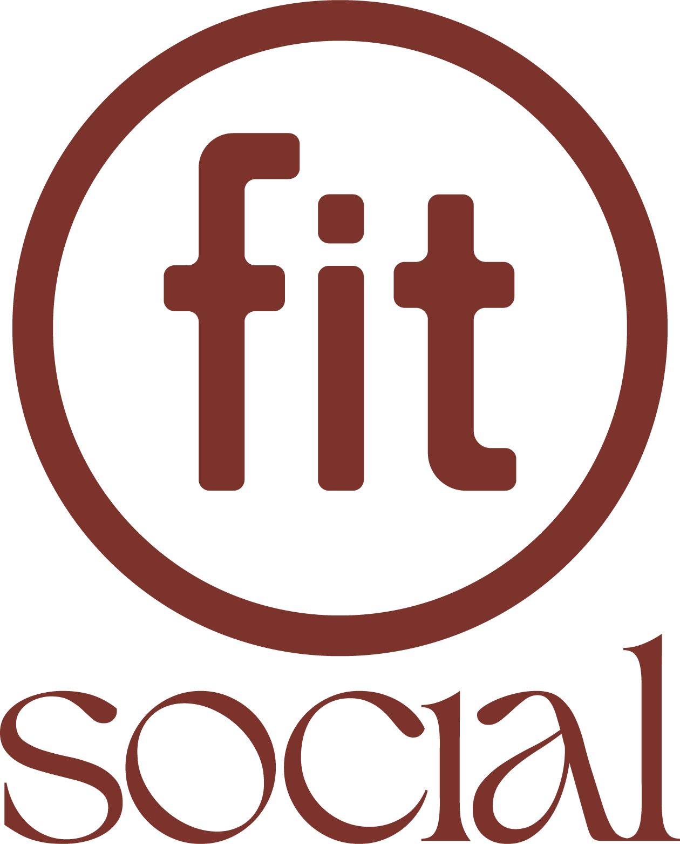

Opening Date: | May 19, 2025
About Fit Social: | Fit Social is a beachfront social wellness space created by Fit Athletic, located at San Diego’s historic Belmont Park in Mission Beach. Open to the public, Fit Social is designed to bring the Fit experience beyond the gym — blending recovery, coworking, dining, and connection in one all-day destination.  Guests can drop in to recharge in oceanfront saunas, relax in the outdoor hot tub, get work done in shaded coworking spaces, or meet friends for food, drinks, and live music. As the day winds down, Fit Social transitions into a vibrant event space with sunset DJs, private events, and weekend festivals — offering a new kind of wellness-meets-social lifestyle on the sand.
Brand Vision: | Fit Social is part of a growing shift toward post-performance wellness — where recovery, connection, and lifestyle are valued as much as training. It’s where people come to move, recharge, and reconnect — no gym membership required.  “Wellness should feel natural, effortless, and part of daily life,” said Scott Lutwak, Founder & CEO of Fit Athletic Club. “People are moving away from isolation — we crave connection, balance, and spaces that support both. Society is shifting toward a more holistic approach to wellness, but the places to support that shift haven’t existed — until now. Fit Social is that space, designed for the way we live today and where we’re headed next.”
Executive Team: | Scott Lutwak, Founder & CEO
Address: | 3125 Ocean Front Walk, San Diego, CA 92109
Hours: | Open daily, 11:00 AM – sunset
Amenities: | - Recovery: Saunas, hot tub, and cold plunges  - Coworking: Dedicated spaces with wireless internet and charging stations  - Food & Beverage: Cold-pressed juices, protein-packed bowls, and craft cocktails  - Events & Entertainment: Live music, DJ sets, and wellness activations
Partnerships: | - Belmont Park – Host location and collaboration partner  - Draft – On-site food & beverage provider  - Acacia + Spruce – Design partner for the Fit Social space
Web/Social: | Website: https://www.fitsocial.com/  Instagram: @fitsocialsd  Facebook:  Tik Tok:

