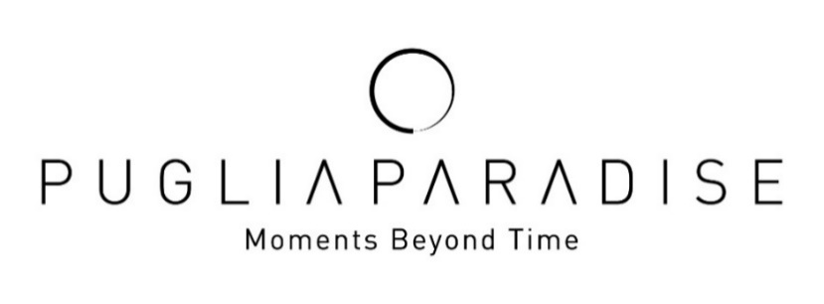
Puglia Paradise: the value of private and personalized
experiences grows in Summer 2026
+50% revenue from additional services and +44% increase in average spending per booking on experiences and add-on services: luxury guests are increasingly choosing Puglia through tailor-made experiences, privacy and authenticity
Milan, September 2026 – In summer 2026, luxury in Puglia is increasingly about the quality of time, privacy and the ability to experience the destination according to personal rhythms and preferences. This is reflected in the season of Puglia Paradise, a company specializing in high-end private villa hospitality in Puglia, which has recorded significant growth in demand for experiences and additional services.
In 2026, the brand recorded a 44% increase in average spending per booking on experiences and additional services, while total revenue generated by these activities grew by 50%. The figures highlight a shift in the habits of luxury travelers: the villa is no longer viewed simply as a place to stay, but as the starting point for creating a complete and personalized experience of the destination.
Among the most frequently requested services are private boat excursions and in-villa dinners with private chefs, alongside growing demand for services enjoyed directly within the property, such as massages, cooking classes, small private events and family-oriented activities. Interest also remains strong in private cultural visits to destinations such as Matera, Lecce and Castel del Monte.
PRIVACY AND PERSONALIZATION: THE NEW DEFINITION OF QUIET LUXURY
“The growth in additional services is particularly significant because it reflects an evolution in the way guests experience the destination. Today, they are not simply looking for a villa or a list of activities, but for an experience built around their individual needs, schedules and way of traveling,” comments Massimo Valentini, Founder and CEO of Puglia Paradise.
Privacy and personalization have indeed become two of the defining expressions of contemporary luxury. An increasing number of guests choose to spend a significant part of their stay at the villa, without giving up the opportunity to enjoy high-quality experiences: a dinner prepared by a private chef, a poolside massage, a cooking class with their children or a private celebration for a family occasion.
Within this model, the Guest Angel® plays a central role as the dedicated point of contact for Puglia Paradise guests throughout their stay, combining in-depth knowledge of the property with local expertise. The aim is to provide personalized and discreet assistance, anticipating guests’ needs and offering genuinely relevant recommendations while avoiding a standardized approach.
IN SEARCH OF A MORE AUTHENTIC PUGLIA, AT THEIR OWN PACE
The search for authenticity has also become increasingly explicit. Guests are showing growing interest in places frequented by local communities, small towns and villages, markets, restaurants and businesses connected to the region’s culinary traditions and local heritage.
The request is not simply to visit Puglia, but to connect with it in a more natural way, away from the most crowded tourist circuits.
A significant example comes from the boat experiences organized by Moments at Sea, Puglia Paradise’s project dedicated to discovering the Puglian coastline. The possibility of departing from the small fishing port of Savelletri allows guests to enjoy a more intimate and authentic experience, in a setting that remains deeply connected to local life.
MOMENTS AT SEA: MORE THAN 80 TOURS IN ITS FIRST SEASON
The first season of Moments at Sea, which began on May 20, 2026, recorded more than 80 tours.
The star of the experience is PIA, a 36-foot Sorrentine gozzo boat able to accommodate up to 18 guests. It features generous open spaces and a beam of 4.5 meters, providing exceptional stability while cruising.
The most popular option was the half-day experience, with four hours of navigation in either the morning or afternoon. This duration allows guests to enjoy the sea at a relaxed pace while still leaving room for other activities during the day.
THE UNITED STATES REMAINS THE LEADING MARKET, WITH CANADA SHOWING STRONG GROWTH
Puglia Paradise’s international dimension remains another defining characteristic of its clientele. The United States continues to be the leading market, accounting for 29% of guests, followed by the United Kingdom at 21%. Canada accounts for 8.5%, Australia for 6%, followed by Italy and other European markets.
Among the markets recording the most significant growth in 2026, Canada stands out, with a 130% increase in revenue. The United States also performed strongly (+27%), as did Australia (+18%) and Germany (+9.4%).
The figures confirm Puglia’s appeal among an international clientele drawn not only by its cultural heritage, gastronomy, lifestyle and the opportunity to enjoy experiences that still feel authentic, but also by the quality of its hospitality.
LOOKING AHEAD TO 2027: THE VALUE OF HUMAN GUIDANCE
Looking ahead to 2027, Puglia Paradise identifies the combination of personalization, privacy and human assistance as one of the key elements set to shape luxury travel in Puglia.
In a context where access to information is increasingly immediate, also thanks to artificial intelligence, the value of a trusted guide capable of selecting what is genuinely suited to each guest is growing.
At Puglia Paradise, approximately 70% of bookings are direct; this figure reaches 100% for the most distinctive properties, selected for their quality, comfort, privacy and design. These percentages highlight guests’ preference for a personal relationship with people who know the property and the destination firsthand and can accompany them throughout their stay.
For Puglia Paradise, the trend set to strengthen in 2027 is therefore one of increasingly “quiet” luxury: less focused on ostentation and more on the quality of time, privacy, simplicity and the ability to feel personally supported while discovering the destination.
About Puglia Paradise
Puglia Paradise specializes in high-end private villa hospitality in Puglia. Through a portfolio of carefully selected properties professionally managed to hotel standards, personalized services and the support of its Guest Angel® team, it offers international guests an authentic and tailor-made way to experience the Puglian territory. In 2026, the company also launched Moments at Sea, a project dedicated to private boat experiences along the Puglian coastline.
CONTACTS
PUGLIA PARADISE
Foro Buonaparte 59, 20121, Milano, Italy
info@pugliaparadise.com
www.pugliaparadise.com
Instagram: @puglia.paradise
Facebook: @pugliaparadise

Per Richiesta Stampe e Interviste Personalizzate
OGS PR and Communication
Via Koristka 3, Milano 20154
+ 02 3450610 - info@ogscommunication.com
www.ogscommunication.com

Visita QUI la newsroom dedicata a Puglia Paradise

