
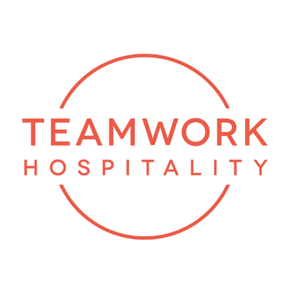

TOURISM: MILAN TO HOST THE WORLD'S LEADING LUXURY HOSPITALITY EXECUTIVES ON 23rd OCTOBER

More than 70 international speakers, 1,000 industry leaders, and top executives from Ritz-Carlton, Leading Hotels of the World and Relais & Châteaux to discuss the future of luxury hospitality.

Milano, July 2026 – On 23 October, Milan will host Italy's leading event dedicated to luxury hospitality. The Luxury Hospitality Conference, organized by Teamwork Hospitality, will take place at the Meliá Milano, bringing together approximately 1,000 General Managers, CEOs, entrepreneurs, investors and hospitality professionals from across Europe.
On 23 October, Milan will host Italy's leading event dedicated to luxury hospitality. The Luxury Hospitality Conference, organized by Teamwork Hospitality, will take place at the Meliá Milano, bringing together approximately 1,000 General Managers, CEOs, entrepreneurs, investors and hospitality professionals from across Europe.

Among the keynote speakers will be Horst Schulze, Founder of The Ritz-Carlton Hotel Company and Founder of Capella Hotel Group, widely regarded as one of the most influential pioneers of modern luxury hospitality. Joining him on stage will be Shannon Knapp, President & CEO of The Leading Hotels of the World, and Laurent Gardinier, President of Relais & Châteaux, for a discussion on the evolution of contemporary luxury, increasingly shaped by authenticity, personalized experiences and the enhancement of destinations.

The conference programme will explore the major trends transforming the industry, including international investment, the expansion of global hotel brands, artificial intelligence, luxury marketing, hotel design, sustainability, talent development and the changing expectations of today's discerning guests.

One of the conference's headline panels will feature development executives from Hilton, Marriott International and Accor, who will discuss growth strategies in the luxury segment and the outlook for international markets. This will be followed by a session featuring some of Italy's leading hospitality investors—including Lefay Resorts & Residences, LDC Hotels & Residences and Egnazia Ospitalità Italiana—who will examine the evolution of the high-end hospitality market and future investment opportunities across Italy.

A significant part of the programme will also be devoted to operational insights from General Managers of some of the world's most prestigious hotels. Executives representing brands such as Mandarin Oriental, Park Hyatt Milan, Orient Express Venice, Royal Mansour Collection, Dorchester Collection, One&Only, The Lake Como EDITION, and other internationally renowned luxury properties will share how leadership, service excellence and guest experience are evolving in the ultra-luxury segment.
Alongside the main plenary sessions, a second conference room will host specialist presentations on hotel architecture and design, luxury sales strategies, international travel trends with Virtuoso, the application of artificial intelligence to customer experience, and executive education, featuring leading institutions including EHL, Glion, Istituto Marangoni and ALMA.

"The Luxury Hospitality Conference was created to bring the very best international thinking on luxury hospitality to Italy and provide a platform where the industry's leading players can exchange ideas," says Mauro Santinato, Founder of the conference and President of Teamwork Hospitality. "Today, luxury is no longer defined solely by service excellence. It is about the ability to innovate, create value and build authentic relationships with guests. These are the challenges that the world's leading hospitality executives will address during the conference."

The conference will be preceded on the evening of 22 October by the third edition of the Best Luxury Hotel Awards, hosted at Milan's historic Hotel Principe di Savoia. The ceremony will celebrate excellence in Italian and international luxury hospitality in the presence of more than 350 hotel owners, General Managers and industry professionals.

The Luxury Hospitality Conference continues to strengthen its position as Italy's leading observatory on the evolution of luxury hospitality, a sector that remains one of the most dynamic drivers of the global tourism industry.

About Teamwork Hospitality
Based in Rimini, Italy, Teamwork Hospitality is one of the country's leading hospitality consulting and training companies, providing strategic advisory services and professional development programmes for the hospitality industry.
Led by President Mauro Santinato, Teamwork Hospitality is recognized as a trusted partner, delivering tailored solutions that help hospitality businesses improve quality, enhance guest satisfaction and maximize profitability.

Contact Information
LUXURY HOSPITALITY CONFERENCE
www.luxuryhospitalityconference.it

TEAMWORK HOSPITALITY
Rimini - Via Macanno 38 Q
Ph. +39 0541 57474
info@teamworkhospitality.com
www.teamworkhospitality.com

Public Relations & Press Office
OGS PUBLIC RELATIONS & COMMUNICATION
Milano - Via Koristka 3
Ph. +39 02 3450610
www.ogscommunication.com
info@ogscommunication.com
press.ogscommunication.com

