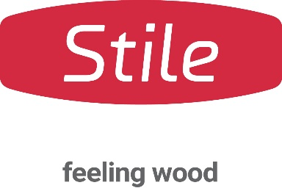

FABRIC COLLECTION

Stile, a leading Umbrian company in the high-quality parquet and wooden flooring sector, presents Fabric, a modern and sensuous collection where innovation, aesthetic research, and traditional craftsmanship come together to create surfaces with a distinctive tactile character.

Fabric translates the soft, enveloping language of textiles into the enduring strength of oak. Inspired by the rhythm of interwoven fibres, each surface is designed to bring depth, movement, and a refined tactile experience to interiors. The result is a parquet flooring collection that dresses spaces with natural elegance, transforming the floor into a true design feature.

Manufactured in Italy as an engineered wood flooring collection, Fabric combines material innovation, design expertise, and artisanal craftsmanship to enhance the authentic beauty of oak. Created for a broad and versatile audience, the collection integrates seamlessly into both contemporary interiors and more classic settings. It is available in 180 mm and 140 mm plank widths, offering a wide range of design possibilities for residential and contract projects.

The result of ongoing research into materials and finishes, Fabric embodies artisanal quality, meticulous attention to detail, and 100% Made in Italy production.

AVAILABLE PRODUCTS AND FINISHES
The collection is now enriched with five new finishes—Hemp, Organza, Angora, Mohair, and Satin—which join the existing shades Jute, Linen, Silk, Cotton, and Velvet. Together, these ten interpretations of oak highlight the wood’s natural texture, tonal nuances, and distinctive character, offering architects and interior designers extensive creative freedom for a wide range of design projects.

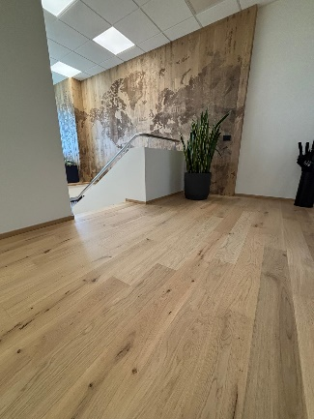
All floors in the collection are available exclusively with the Naturale UV finish, developed to provide durable yet invisible protection. Soft to the touch, the surface has an exceptionally matte, natural appearance that faithfully recreates the look of unfinished wood.
Figura 1 - Fabric
As environmentally friendly and naturally beautiful as an oil finish, yet significantly easier to maintain, Naturale UV is also the world's first lacquer finish to allow for localized surface repairs, making it possible to restore only the affected area without refinishing the entire floor.

Stile Società Cooperativa
Via dei Laghi, 18 – Trestina, Città di Castello (PG) – Italy
www.stile.com
stile@stile.com
Tel. +39 075/854706

Per richieste stampa e interviste personalizzate:

OGS PR and Communication

Via Koristka 3, Milano
+39 02 3450610
info@ogscommunication.com
www.ogscommunication.com
press.ogscommunication.com

