


Angelo Cappellini & Opera Contemporary and the Villa Jolanda project in Brunate on Lake Como



Set on the hills of Brunate overlooking the breathtaking panorama of Lake Como, Villa Jolanda becomes the stage for an interior design project that celebrates the excellence of Italian design and craftsmanship through the intervention of Angelo Cappellini and Opera Contemporary, created in collaboration with Garamonds.

Nestled within an architecturally charming setting, the villa has been reinterpreted through an interior design project capable of enhancing its historical identity with an elegant, sophisticated language perfectly in harmony with the atmosphere of the location. Taking center stage in the project are furnishings by Opera Contemporary and Angelo Cappellini, carefully selected to create a harmonious dialogue between historical heritage and contemporary sensibility.

The rooms of the residence feature a refined selection of Clarissa, Osiride, and Ivette beds by Opera Contemporary, complemented by furnishings distinguished by soft lines, fine materials, and delicate beige and natural tones. The interiors blend seamlessly into the villa’s original spaces, helping to shape intimate and relaxing environments designed to offer an exclusive and contemporary hospitality experience.

The designer beds by Opera Contemporary express a welcoming, warm, and sensual aesthetic, achieved through the use of fine materials, artisanal craftsmanship, and a rich variety of textures that enhance the feeling of comfort and intimacy. The color palettes, dominated by natural tones with occasional accents of color, define refined and contemporary environments in which the bed becomes the absolute centerpiece of the bedroom space.

The bedroom, the most personal space in the home, thus transforms into a private retreat away from daily stress: a place dedicated to relaxation, wellbeing, and the restoration of one’s energy.

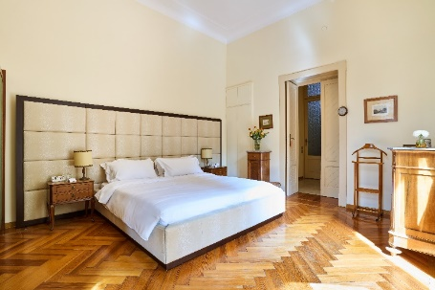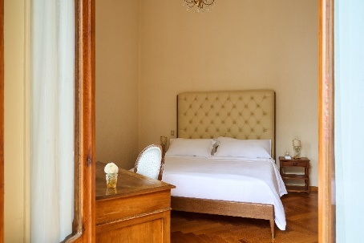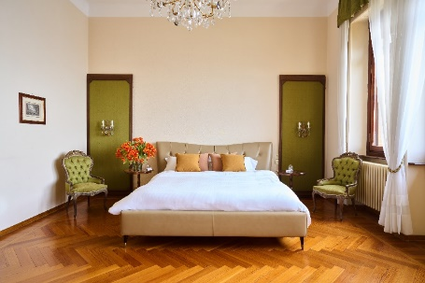

A distinctive element of the project is also the wooden dependency separated from the main villa, conceived as an elegant space dedicated to the traditional “five o’clock tea.”
Angelo Cappellini interprets the charm of great Italian decorative tradition through a Louis XV-style living room composed of sofas, armchairs, chairs, and coffee tables with crystal tops. The artisanal craftsmanship, carved details, and fine finishes fully express the brand’s savoir-faire, creating an environment with a refined and timeless character.

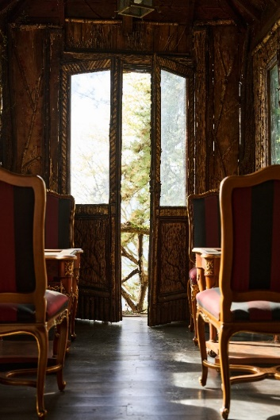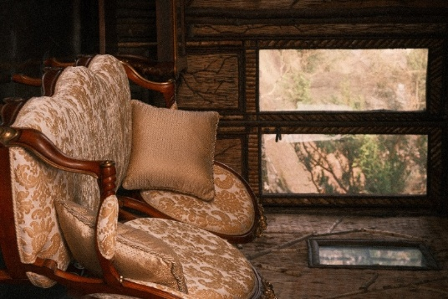

The intervention at Villa Jolanda highlights the ability of Angelo Cappellini and Opera Contemporary to design environments where aesthetics, comfort, and identity coexist in perfect balance. It is a project that interprets contemporary luxury through manufacturing quality, stylistic research, and the enhancement of Italian heritage, set in one of the most iconic and internationally renowned destinations of the Lake Como area.

The collaboration with Garamonds arose naturally, driven by a shared vision of hospitality and the authentic value of Italian lifestyle. Villa Jolanda represents a place capable of attracting an international clientele seeking not only an exclusive destination, but an experience deeply rooted in tradition, elegance, and a culture of beauty.

From the very early stages of the project, a strong synergy emerged among the companies involved, united by the desire to enhance the historic character of the villa through furnishings and atmospheres capable of expressing Italian craftsmanship. This is a language made of artisanal details, refined materials, and high-end manufacturing techniques, designed for an international audience that recognizes Italy as a global benchmark for style and quality.

In this context, the collaboration between Angelo Cappellini, Opera Contemporary, and Garamonds has helped create environments that are fully consistent with the soul of the villa, where contemporary design and classical tradition coexist in perfect balance, offering guests a sophisticated and timeless experience.
About Angelo Cappellini
Angelo Cappellini is the excellence of classic Italian furniture: a family-run, multi-generational story that has redefined the concept of elegance and artisanal mastery in the world of interior design. Today, the company stands on the international design stage in both classic and contemporary segments, supported by deep experience and extensive industry knowledge.

About Opera Contemporary
Since 2010, Opera Contemporary has represented a benchmark in high-end furnishings, blending artisanal tradition and contemporary design into a unique vision of luxury. The brand stands out for its ability to adapt elegantly to both exclusive residential environments and hospitality spaces, offering a collection that celebrates attention to detail and manufacturing excellence. Thanks to collaborations with internationally renowned designers, each creation becomes a perfect balance between aesthetics and functionality, designed to meet the needs of a sophisticated and cosmopolitan clientele.

