

Segis, a renowned company for its table, seating, modular system, and furnishing complements designs, presents new elements for solutions for the Contract world, capable of inhabiting indoor spaces and outdoor landscapes with the same natural grace, designed by Studio Zest.

A new collection that celebrates design maturity through the total mastery of materials. From the technical precision of the metals to the versatility of plastic reaching the welcoming embrace of upholstery: every piece is a testament to our artisanal and industrial expertise.

In every curve, every joint, and every finish, lies the signature of a company, Segis, that knows how to transform matter into style, offering beauty and character to those who live in collective spaces, standing strong in tradition while vibrating with a new, creative energy.

THE DEBUT OF THE NEW SEGIS COLLECTIONS BY Studio Zest.

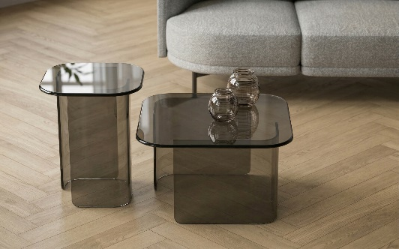
GLOSS
Segis presents Gloss coffee tables, which represent an exquisite blend of expert craftsmanship and sober elegance. Entirely realized in smoked or bronze glass, this delicate set of tables combines transparency and smooth organic shapes, resulting in a sophisticated and versatile design.

Figura 1 - Gloss

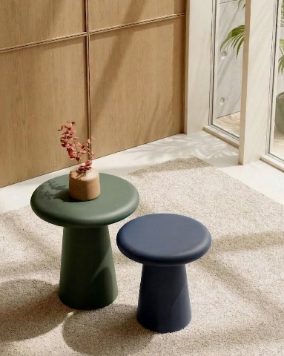
BLAST
Figura 2 - Blast
A burst of color that brings character to any space, Blast is a side table available in two heights, crafted from painted metal. A versatile and contemporary solution, ideal for adding character to the lounge area. Placed next to the sofa, it complements moments of relaxation, offering a practical surface for a good book or a cup of coffee.

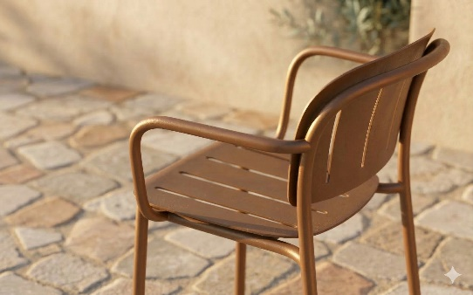
CAPOEIRA
A new rhythm to outdoor spaces with Capoeira, colorful, lightweight, and stackable, this 100% aluminum chair is the winning move to enjoy ultimate relaxation during the sunny season. The collection is complete with a stool available in two heights and a comfortable lounge chair.

Figura 3 - Capoeira

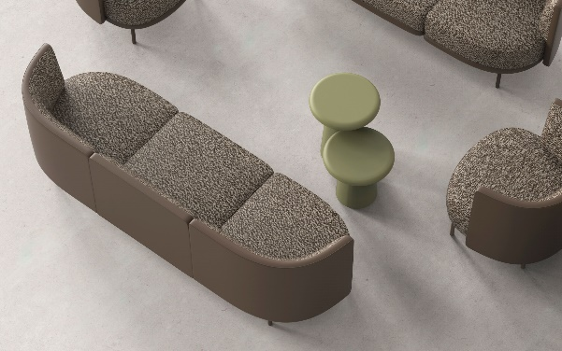
ROUND UP
Figura 4 - Round Up
Round UP is true architecture designed for lounge and waiting areas. This seating system stands out for the exceptional comfort of its seats and backrests, conceived to welcome you into a nest of pure relaxation. Capable of adapting to any spatial requirement through endless modularity, Round UP offers the versatility to create custom relaxation islands, seamlessly integrating spacious, elegant tables into the configuration.

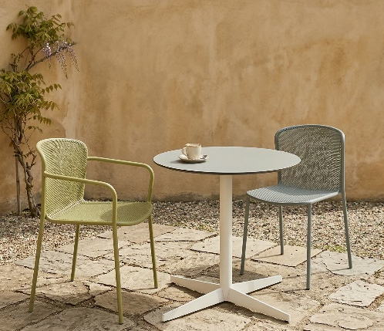
MIRAGE
As light as a mirage, as solid as metal. The Mirage outdoor chair enchants with its microperforated seat shell: a visual play of voids and solids that dematerializes its forms. Stackable and colorful, it is pure magic for outdoor spaces.

Figura 5 - Mirage

SEGIS
Via Umbria 14
53036 Poggibonsi, SI, Italy
www.segis.it

For press requests and personalized interviews:

OGS PR and Communication
Via Koristka 3, Milano
+39 02 3450610
www.ogscommunication.com - press.ogscommunication.com
info@ogscommunication.com

