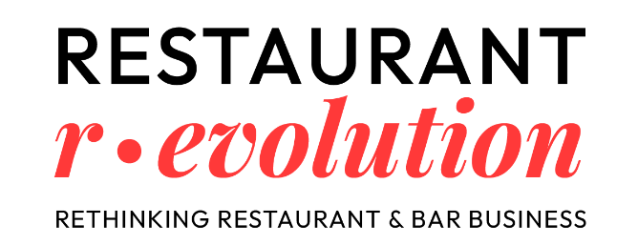
RESTAURANT R-EVOLUTION: GREAT TURNOUT FOR THE FIRST EDITION OF THE EVENT DEDICATED TO SUCCESS IN THE RESTAURANT INDUSTRY
The first edition of Restaurant R-Evolution was met with great enthusiasm. This new event—the first in Italy dedicated to exploring what truly goes into creating a successful restaurant—was organized by Teamwork Hospitality and made its debut at the Melià Milano on March 31, 2026.
From business models to technology, from emerging formats to design, and all the way to the evolving needs of today’s consumers, Restaurant R-Evolution guided attendees through a full day focused on understanding how the restaurant industry is changing and what the real competitive drivers are today for building a solid, profitable, and long-lasting venture.
With over 550 participants, 35 partner companies, and a program featuring 80 Italian and international speakers, the event provided a unique opportunity to bring together restaurateurs, entrepreneurs, hoteliers, designers, consultants, and industry professionals, creating a stimulating environment for the exchange of ideas and knowledge.
“In recent years, we’ve seen tremendous growth in events dedicated to food—cuisine, techniques, chefs, products. But we realized something fundamental was missing. There was no opportunity to discuss everything that determines a restaurant’s success even before the first dish leaves the kitchen. There was a lack of space to talk about ideas, concepts, business models, design, branding, numbers, and sustainability,” said Mauro Santinato, President of Teamwork Hospitality.
“We deeply believe that today the real value lies not only in ideas, but in relationships. In the cross-pollination between different worlds. In the exchange between those who design, invest, manage, and innovate. That’s why we wanted Restaurant R-Evolution to also be a true networking space—where collaborations, opportunities, and new projects are born. Because the best ideas rarely come from working alone. They come from working together,” Santinato continued.
The first edition featured prominent speakers from the Horeca world, including top experts from Majestas Group, Zuma Restaurants, Giraudi Group, Caprice Holding, Paris Society, Gioia Group, Signorvino, Macellaio RC, Kebhouze, Giangusto, La Romana, Cioccolatitaliani, Maré, Ikoyi, Moebius, Hotel Portrait Milano, Lungarno Collection, Hotel Principe di Savoia, Dorchester Collection, The Carlton and Rocco Forte House, The Lake Como EDITION, Valtur Cervinia Cristallo Ski Resort, TheFork, Soplaya, Deliverect, EHL, ALMA, and many others.
Throughout the day, the Main Stage hosted architects, entrepreneurs, and consultants leading the transformation of food & beverage, offering bold visions, winning strategies, and authentic behind-the-scenes insights. The Innovation Talks explored key industry trends—from sustainability to customer experience—analyzing real changes and new business models. With the Lab Experience, participants engaged in hands-on workshops and guided simulations, turning ideas into real projects with the support of professionals. The Taste Expo offered a tangible experience of innovation, featuring an exhibition area dedicated to the contract sector, where attendees could discover furnishings, professional kitchens, and advanced technologies for designing outstanding F&B spaces. In addition, networking opportunities were created in a dynamic environment connecting designers, suppliers, and investors, encouraging dialogue and the development of valuable partnerships.
The success of the first edition of Restaurant R-Evolution confirmed the event as a key reference point for an ever-evolving industry, establishing a strong foundation for future editions and fueling the enthusiasm and curiosity of those eager to further explore the contemporary restaurant landscape.
About Teamwork Hospitality
Based in Rimini, Teamwork Hospitality is a consulting, training, and events company dedicated to the hospitality industry, with over 25 years of experience and more than 15 events annually. Led by President Mauro Santinato, Teamwork Hospitality is a reliable and experienced partner, capable of delivering tailored services that ensure the best results in terms of quality, customer satisfaction, and business profitability.

INFO E CONTATTI
www.restaurantrevolution.it
E-mail: info@teamworkhospitality.com
Tel. +39 0541 57474
Per richieste stampa, interviste personalizzate e maggiori informazioni:

OGS PUBLIC RELATIONS & COMMUNICATION
Milano - Via Koristka 3, (Italia)
Ph. +39 023450610
www.ogscommunication.com – press.ogscommunication.com
info@ogscommunication.com

