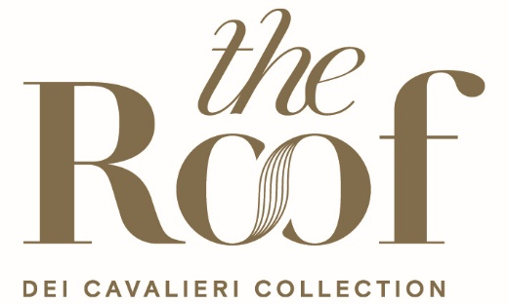

THE ROOF MILANO BAR & RESTAURANT

A breathtaking view of the Milan skyline, at any time of the day, this is The Roof Milano Bar & Restaurant, a spectacular panoramic terrace on the tenth floor of the building that houses the Hotel Dei Cavalieri – Milano Duomo and the Hotel The Square – Milano Duomo, part of the renowned hotel chain Dei Cavalieri Collection.

Located just steps from the Duomo, The Roof Milano Bar & Restaurant welcomes both guests of the two hotels and external visitors every day for lunch, aperitif, dinner, and after-dinner.
The Roof Milano Bar & Restaurant features an indoor area of approximately 120 square meters and a 390 square meter outdoor terrace, where you can relax and enjoy the stunning view.

The terrace offers a unique perspective, allowing guests to enjoy unmissable views, while inside, the room stands out with its contemporary design, featuring elegant furnishings in dark tones that create a sophisticated and refined atmosphere. A distinctive element of the room is the full-wall screen, where selected and personalized projections can be displayed, combining the culinary experience with an immersive visual experience. With its refined ambiance and high-quality service, it is the perfect place to enjoy special moments, immersed in the beauty of Milan.

The restaurant, open every day, offers typical Milanese cuisine that extends to a more Mediterranean style, rich in aromas and flavors. The light lunch option makes it the perfect meeting spot for those looking to organize business appointments in a discreet, refined, and elegant setting, or simply for those who want to enjoy the city from above.

The Roof Bar & Restaurant is also the perfect location for a refined outdoor aperitif, where you can enjoy a spectacular sunset over the old Milan while sipping cocktails expertly crafted and mixed by the bartenders, accompanied by small savory delicacies. In addition, there is a "to share" menu offering a selection of dishes to choose from, making it an ideal spot for a delightful evening.

For those wishing to spend an evening in good company, The Roof restaurant offers a fine dining experience, always in search of carefully selected ingredients and flavors to make the experience truly unique. Set in a one-of-a-kind context, guests can watch the sun set and the city light up for the night, enhancing the unforgettable atmosphere.

At The Roof Milano Bar & Restaurant, excellent seasonal products are paired with an extensive selection of fine and renowned Italian and international wines, all under the expert guidance of Chef Mauro Sgroi and his team.

In the evening, The Roof Milano Bar & Restaurant transforms into a modern and sophisticated lounge bar, offering a selection of drinks ranging from classic options to signature cocktails that define the venue. Among these, the standout cocktails include The Roof Fashion (made with Macallan, Zacapa 23, Cacao Angostura, Sugar Syrup, and garnished with Modica Chocolate) and the Raspberry Breeze (featuring Belvedere Vodka, Vanilla Liqueur, Raspberry Purée, Lemon Juice, Blueberry Juice, and garnished with raspberries).

On Thursday, Friday, and Saturday nights, The Roof Milano Bar & Restaurant comes alive with DJ sets and music, creating a convivial and relaxing atmosphere perfect for enjoying the company of friends and family. It offers a unique experience where high-quality entertainment blends with the elegance and comfort of an exclusive setting, allowing guests to enjoy unforgettable moments of leisure and pleasure.

The Roof Milano Bar & Restaurant is the ideal place to celebrate any type of occasion, from corporate events to life's most special moments. Guests can fully experience the magic of Milan with a complete view of the city, from the rooftops of historic buildings to the modern skyline of Citylife.

About Dei Cavalieri Collection

Dei Cavalieri Collection is a renowned hotel group long established in the Italian hospitality, under the leadership of the Milanese Bernardelli family, now in its third generation. The Group boasts a collection of four hospitality establishments and food & beverage activities strategically located in the heart of Italy's major cities, close to both tourist attractions and business centers. In Milan, there are The Square Hotel - Milano Duomo and Hotel Dei Cavalieri - Milano Duomo, located in Piazza Missori just steps away from the Duomo, along with the renowned panoramic terrace The Roof Milano Bar & Restaurant, offering a 360-degree view of Milan's skyline. In Florence, nestled in the city center among medieval alleys and Renaissance squares, stands Hotel Monna Lisa - Florence, a historic residence with a unique charm, surrounded by a beautiful private garden. In Caserta, Hotel Dei Cavalieri - Caserta La Reggia is situated near the majestic Reggia di Caserta.

Dei Cavalieri Collection
Milano | Caserta | Firenze
www.deicavaliericollection.com

The Roof Milano Bar & Restaurant
Via Alberico Albricci 2/4 - Milano
info@theroofmilano.com
+39 02 88 57 900

For press inquiries and information:

OGS PR and Communication
Via Koristka 3, Milano
www.ogscommunication.com – press.ogscommunication.com
info@ogscommunication.com
+39 02 3450610

