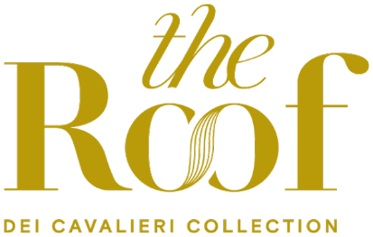

Valentine’s Day with a view over Milan: the romantic experience of The Roof Milano Bar & Restaurant
On the occasion of Valentine’s Day, The Roof Milano Bar & Restaurant, the spectacular panoramic terrace on the tenth floor of the building that houses Hotel Dei Cavalieri – Milano Duomo and Hotel The Square – Milano Duomo, both part of the prestigious Dei Cavalieri Collection, offers exclusive menus designed to celebrate love in one of the city’s most evocative locations.

With a breathtaking view over the Milanese skyline, The Roof Milano confirms itself as the ideal setting for an aperitif or a romantic dinner for two, defined by elegance and refined taste.

On February 14, from 6:00 pm to 8:30 pm, the rooftop welcomes guests for a special sunset aperitif, accompanied by the signature cocktail of the day, “Coup de Foudre,” alongside a selection of great classics. The food offering includes bread with Normandy butter and Baikal caviar; tartlet with fermented vegetable tartare; marinated salmon rose with yuzu kosho; mini bao with pulled beef and sesame sauce.

For those seeking a romantic dinner, starting from 9:00 pm it will be possible to enjoy a tasting menu specially created by the Chef for the occasion. The experience begins with a vol-au-vent filled with a salmon rose and raspberry powder, paired with a glass of Mosnel Franciacorta Brut, followed by roasted king prawns with avocado petals and guacamole.

The first course is a refined San Massimo Reserve cacio e pepe risotto with raw Mazara red shrimp, while the main course features a braided sea bass with purple potato purée and tarragon. To conclude the evening, a themed dessert: a pistachio bavarois heart with a strawberry insert.

A complete sensory experience suspended between sky and city, to celebrate Valentine’s Day with style and passion.

About Dei Cavalieri Collection
Dei Cavalieri Collection è un rinomato gruppo alberghiero a lungo affermato nel panorama dell’ospitalità italiana, sotto la guida della famiglia milanese Bernardelli, giunta alla terza generazione. Il Gruppo conta oggi all’attivo una collezione di quattro strutture ricettive e attività food&beverage nel cuore delle principali città italiane posizionandosi strategicamente vicino ai punti di interesse sia turistico che d’affari.
Milano ospita l’Hotel The Square – Milano Duomo e l’Hotel Dei Cavalieri – Milano Duomo, in Piazza Missori a pochi passi dal Duomo, e la nota terrazza panoramica The Roof Milano Bar & Restaurant, da cui ammirare lo skyline del capoluogo lombardo a 360° gradi. A Firenze, in pieno centro, tra vicoli medioevali e piazze rinascimentali, sorge l'Hotel Monna Lisa - Firenze, una dimora storica dotata di uno charme unico, circondata da uno splendido giardino privato, mentre a Caserta l’Hotel Dei Cavalieri - Caserta La Reggia si colloca vicino alla maestosa Reggia di Caserta.

Dei Cavalieri Collection
Milano | Caserta | Firenze
www.deicavaliericollection.com

The Roof Milano Bar & Restaurant
Via Alberico Albricci 2/4 - Milano
info@theroofmilano.com
+39 02 88 57 900

Per interviste e richieste stampa:

OGS PR and Communication
Via Koristka 3, Milano
www.ogscommunication.com – press.ogscommunication.com
info@ogscommunication.com
+39 02 3450610

