
RION, design by Basaglia + Rota Nodari

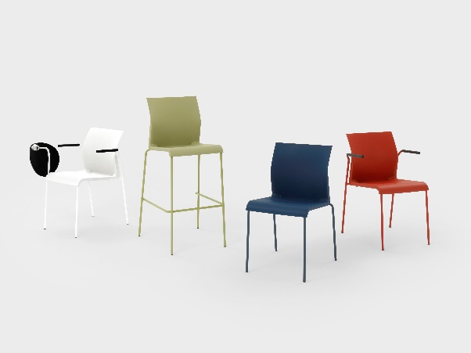
Segis, a renowned company for its table, seating, modular system, and furnishing complements designs, presents RION, its new seating line inspired by the 2009 IRON collection designed by the Italian design master, Carlo Bartoli.

IRON evolves into RION in the current redesign by studio Basaglia + Rota Nodari. This new guise acknowledges the iconic product and its inherent value, offering timeless seating solutions.

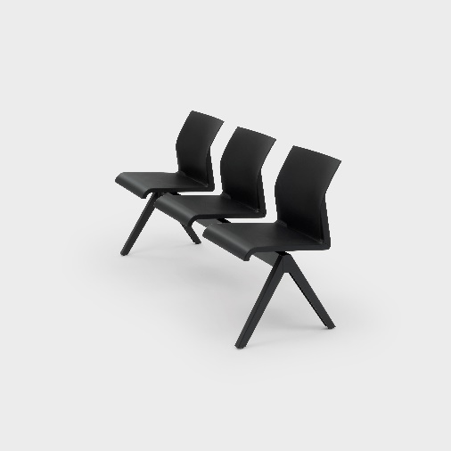
The Basaglia + Rota Nodari studio has intervened on the IRON project through a redesign process that represents a common thread uniting the past, present, and future of Segis.

RION is a chair characterized by fluid lines, lightweight yet robust, ideal for gathering spaces and capable of becoming a reference point in the hospitality sector. The chair's structure, available in both metal rods and tubular forms, as well as in the four-legged version, supports a seat and backrest made of polypropylene. This design offers a combination of lightness and strength, essential to meet the needs of dynamic environments such as gathering and hospitality spaces.

RION is offered in numerous variations and colors, including tone-on-tone combinations, thus providing a wide range of aesthetic choices to adapt to different contexts. Its versatility makes it suitable for both informal settings and more formal contexts, adding a touch of style and functionality to any space.

SEGIS
Via Umbria 14
53036 Poggibonsi, SI, Italy

For press inquiries and personalized interviews:
OGS PR and Communication
Via Koristka 3, Milano
+39 02 3450610
www.ogscommunication.com - press.ogscommunication.com
info@ogscommunication.com

