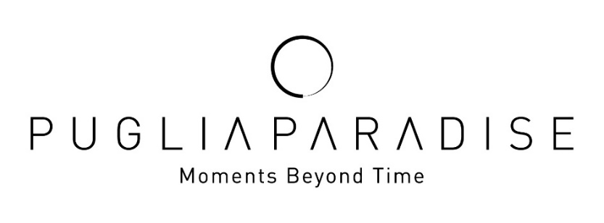

Puglia Paradise strengthens its positioning in quiet luxury with an increasingly human, relational and experiential hospitality model

Puglia Paradise, a brand collection of trulli and villas in Puglia, closes 2025 with important results that confirm the solidity of its business model and its distinctive positioning in the quiet luxury segment.

In the year just ended, Puglia Paradise recorded a +26% growth in bookings thanks to the excellent performance of the villas already in the portfolio. This result has consequently led to further growth and expansion in 2026 with four new properties under management: Villa Maggio, Trullo Regiorgio, Trullo in Cima and Casale La Cupa join the Puglia Paradise world, bringing the total number of units to 34 in the Valle d’Itria, among the iconic destinations of Ostuni, Alberobello, Martina Franca and Monopoli.

The additional experiences and extra services offered by Puglia Paradise recorded a growth of 56%, coming to represent around 10% of total revenue. Among the most requested activities, boat excursions and private chef dinners confirmed how carefully designed, authentic and local moments are key to attracting high-quality guests with significant spending power.

“Looking ahead to 2026, Puglia Paradise aims to consolidate its growth path and further strengthen the brand’s identity, increasingly oriented toward an idea of hospitality made of ‘Moments Beyond Time’—original and memorable experiences designed to leave a lasting impression. The goal is to continue expanding the experiential offering, enhancing value-added services and consolidating Puglia Paradise’s positioning as one of the leading references for quiet luxury in Puglia and in the international high-end hospitality landscape,” says Massimo Valentini, Founder of Puglia Paradise.

These results and this vision have led to the confirmation of the investments made in 2025 by Puglia Paradise, which took an important step in the evolution of the group’s experience ecosystem with the launch of “Moments at Sea,” the new business unit operational in 2026 dedicated to sea experiences, and with the introduction of the private boat PIA, a handcrafted Sorrento-style gozzo, which will sail between Savelletri and Taranto for exclusive excursions lasting from three to seven hours and for seasonal activities such as Dolphin Watching. This initiative represents a new potential growth driver, with an estimated contribution of around 5% of total revenue, and is fully integrated into the company’s digital systems, with bookings manageable directly via the app and the Guest Angel service.

Growing digital numbers

In 2025, Puglia Paradise reached 2 million users globally through digital marketing, confirming the international reach of the brand and its ability to attract new potential guests. The website recorded over 150,800 unique visitors, of whom 15,140 returned multiple times, demonstrating steady and growing interest in the offering. User engagement was particularly significant, with a rate of 47.7% and over 71,900 visitors checking availability and prices— a clear indicator of high-quality, purchase-oriented traffic—confirming the effectiveness of the digital strategy and the brand’s international relevance. Puglia Paradise’s SEO activities led to a 38% year-on-year increase in organic traffic and a 30% growth in keywords ranking on the first page of search engines, confirming the brand’s online visibility.

The key role of the Guest Angel
71% of reviews mentioned the names of the Guest Angels. This confirms how human connection, availability and personalized care are central elements of every Puglia Paradise stay. The Guest Angel is the emotional heart of the brand: a dedicated person who makes the experience unique and memorable. With deep local knowledge of the territory, an international perspective and familiarity with the destination, the villa and its services, the Guest Angel ensures that every detail is taken care of, turning every moment into a smooth, pleasant and memorable experience.

Puglia Paradise markets
During 2025, Puglia Paradise welcomed over 1,900 guests from all over the world, helping to consolidate Puglia’s reputation as a leading international luxury destination.

As for international markets, the United States and the United Kingdom are confirmed as the main source markets: in 2025, American guests represented 25% of the total and UK guests 22.9%, standing out as the most loyal and enthusiastic segment of the Puglia Paradise experience. Italy follows with 8.9%, and the Australian market is growing, reaching 5.8%.

Puglia Paradise’s social and environmental commitment

Puglia Paradise continues to strengthen its environmental and social commitment. In the heart of Salento, the area most affected by the “Xylella fastidiosa” epidemic that has devastated over 21 million olive trees, the company has for years been running a reforestation project in collaboration with Olivami, an association committed to safeguarding Apulian olive growing. In 2025, 200 resilient olive trees were planted, and in 2026 another 200 new trees are planned, of which 150 in Salento and 50 at a managed villa, contributing concretely to the protection of the territory and landscape. These initiatives aim to regenerate local landscapes, support Apulian farmers and absorb around 50 tons of CO₂ per year, offsetting the emissions generated by guest travel and the company’s operational logistics.
Contacts
PUGLIA PARADISE
Foro Buonaparte 59, 20121, Milano, Italy
info@pugliaparadise.com
www.pugliaparadise.com
Instagram: @puglia.paradise
Facebook: @pugliaparadise

For press interviews
OGS PR and Communication
Via Koristka 3, Milano 20154
+ 02 3450610 - info@ogscommunication.com
www.ogscommunication.com

