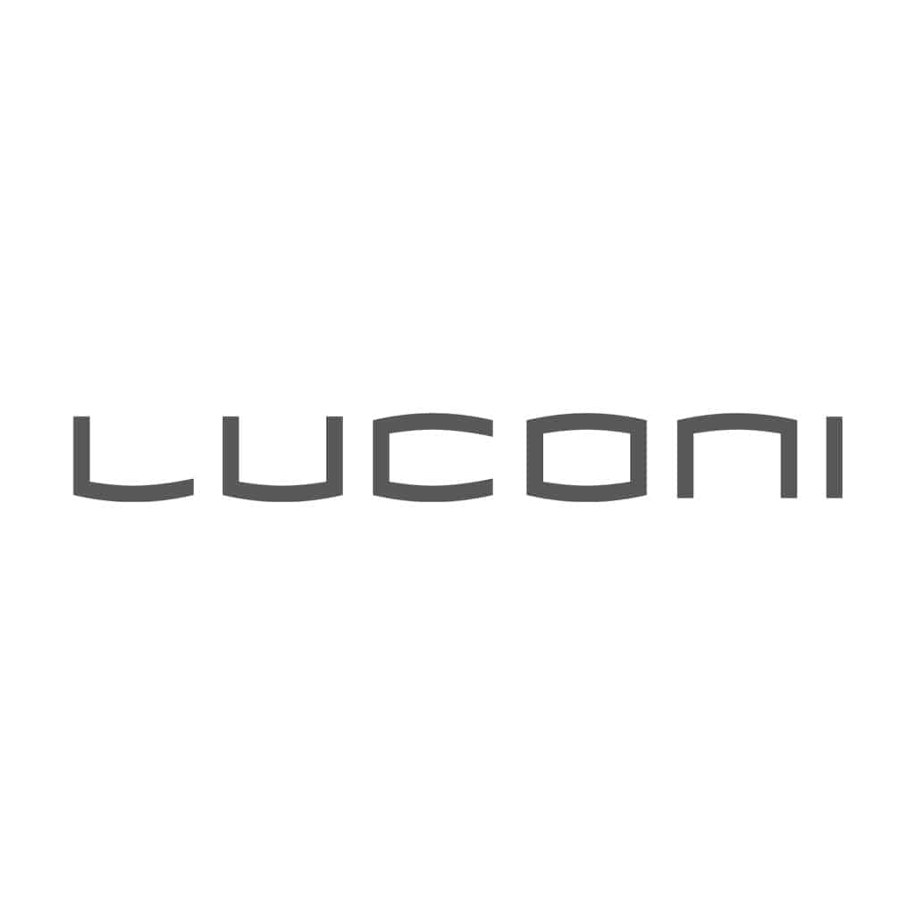

**CHAMELEON BY LUCONI SELECTED FOR THE ADI DESIGN INDEX 2025.**

**A SYSTEM DESIGNED BY IL PRISMA AND DANILO PREMOLI**

**Chameleon** by **Luconi**, a company specialized in the design and creation of innovative glass/aluminum partition wall and door systems, has been selected by the ADI Permanent Design Observatory for inclusion in the **ADI Design Index 2025**. The announcement took place on **Wednesday, October 15, 2025**, at the ADI Design Museum in Milan.

**Chameleon** is a new design concept by Luconi created to meet the needs of contemporary spaces, developed in collaboration with Il Prisma, a renowned international architecture and design firm, and architect and designer Danilo Premoli.

“*We are honored to have Chameleon included, a system that looks to the future through sustainable innovation and modular design. This recognition makes us proud of the development of projects driven by the need for interconnection and dialogue between people, experiences, and spaces*,” said Diego Baiocchi, CEO of Luconi.

Chameleon aims to redefine residential and professional environments, offering solutions that seamlessly adapt to any architectural context.

As its name suggests, Chameleon is a new modular and decorative wall system with **interchangeable** panels. Thanks to its high **compositional flexibility**, Chameleon represents an ideal furniture solution for easily renewing the aesthetics of a space. Its distinctive feature is the innovative **magnetic system**, which uses a supporting structure with decorative panels fixed by magnets. This allows for **extremely simple application and installation**, making each element easily removable, replaceable, and reconfigurable.

I prodotti selezionati nell’ADI Design Index 2025 vengono pubblicati in un volume e la selezione 2025 rappresenta il primo passo verso il **Premio** **Compasso d’Oro ADI 2026.** Il Premio Compasso d'Oro ADI è il più antico e autorevole premio mondiale di design, con lo scopo di mettere in evidenza il valore e la qualità dei prodotti del design italiano.

**ADI Design Index** conferisce dal 2008 tre **Premi per l'Innovazione** chevengono assegnati ogni anno ai progettisti il cui progetto, prodotto o servizio (pubblicato sull'ADI Design Index di quell'anno) si distingue particolarmente per l'innovazione nei materiali, nei processi, nelle tecnologie, oppure nel cambiamento dei comportamenti individuali e sociali, nella critica, nella ricerca applicata.

The ADI Design Index aligns with the Italian Capitals of Culture initiative. The exhibition featuring the Chameleon system will be open to the public from **October 16 to 30, 2025, at the ADI Design Museum** in Milan, before moving to **Agrigento, Italian Capital of Culture 2025, where it will open on November 11 at the Palacongressi and remain open from November 12 to 28, 2025.**

**ABOUT LUCONI**

Luconi, founded in 1978 in Ancona, Marche, is a company specialized in the **design** and creation of **innovative glass/aluminum partition** **wall** and **door systems.**

Under the direction of Vanessa Luconi and Diego Baiocchi, the company has been a reference for over four decades for architects, interior designers, and international interior furniture companies, offering modular solutions tailored to meet the needs of clients in the residential, contract, Ho.Re.Ca, and retail sectors.

*Glass partition systems, sliding and hinged doors, bookshelves and storage units, reception desks, or self-supporting glass booths*—Luconi's great flexibility makes its systems ideal for a wide range of dynamic environments such as private residences, public spaces, offices, and stores with different complexity and size.

**Luconi & C Srl**

Via Luigi Albertini 3, Ancona - Italia

+39 071 286 8404

[luconi.net](https://luconi.net/)

[info@luconi.net](mailto:info@luconi.net)

**OGS PR and Communication**

Via Koristka 3, Milano

+39 02 3450610

[www.ogscommunication.com](http://www.ogscommunication.com)

[press.ogscommunication.com](https://press.ogscommunication.com/)

[info@ogscommunication.com](mailto:info@ogscommunication.com)