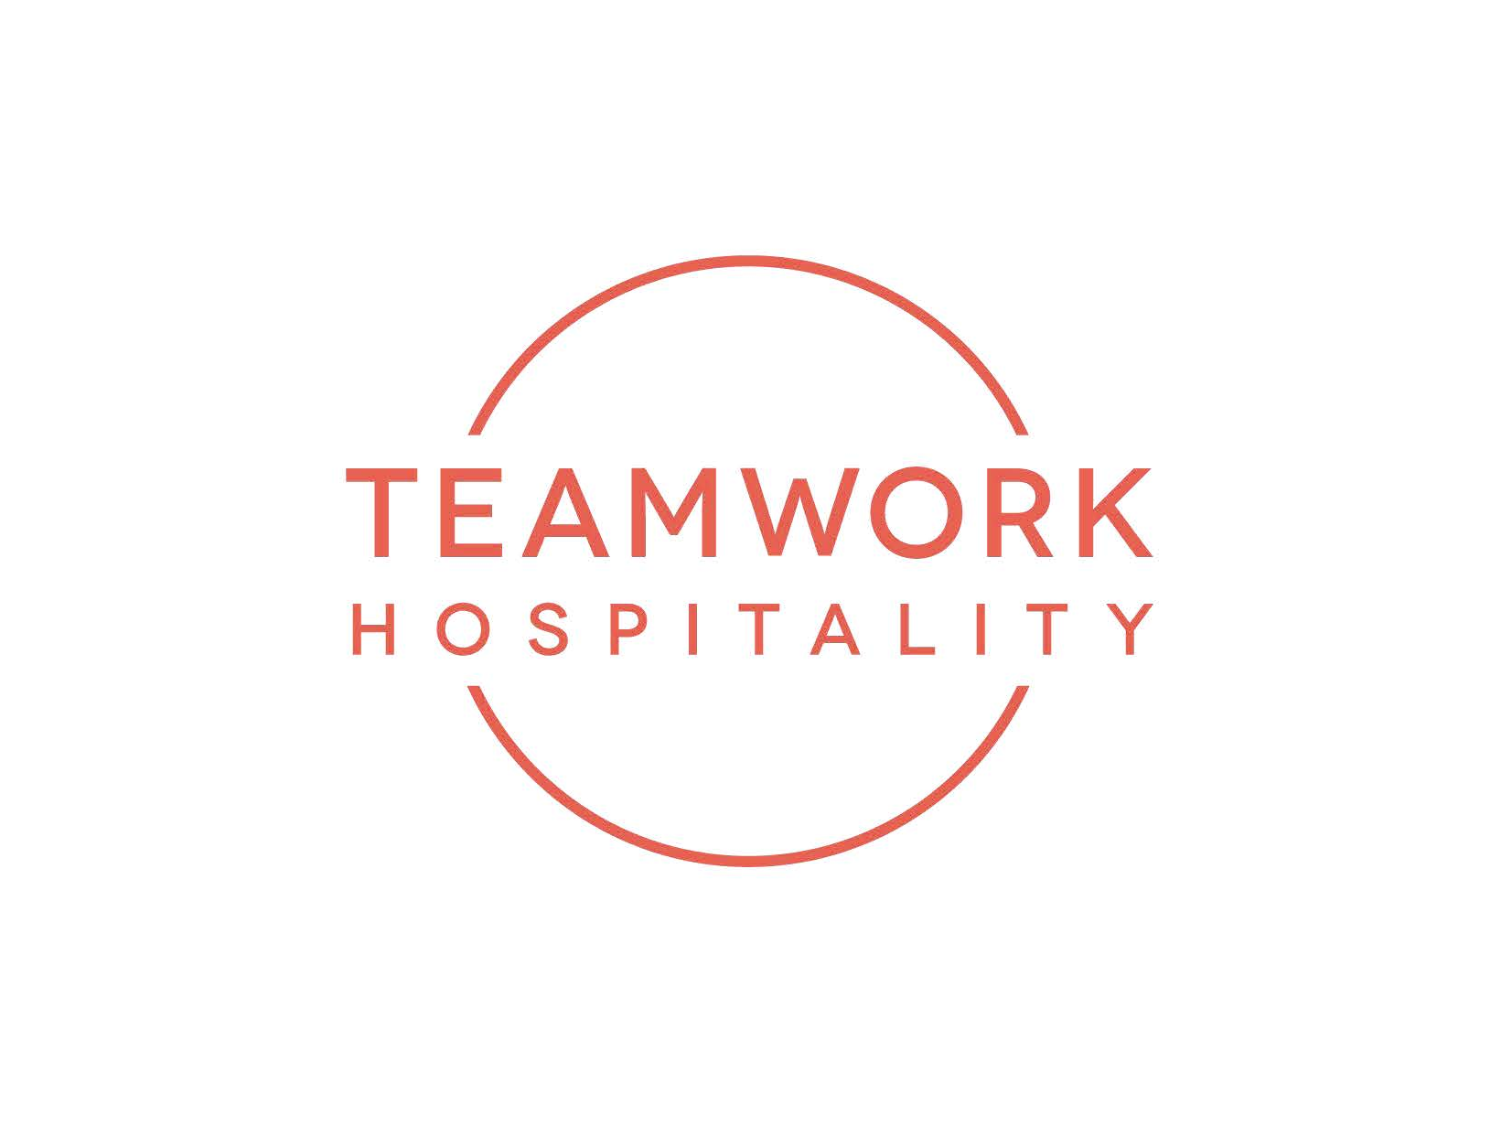

Hospitality Day 2025 continues to inspire those who host.

Italy’s largest hospitality event was held in Rimini on October 7th, setting out new visions for the future of the industry.

Rimini, Palacongressi – Hospitality Day, the annual event dedicated to tourism, hospitality, and future trends in the accommodation industry, celebrated its twelfth edition on October, 7, 2025 at Palacongressi di Rimini.

Conceived and organized by Teamwork Hospitality, a hotel consulting and training company based in Rimini with over twenty years of experience in the tourism and hospitality industry, Hospitality Day reaffirms its role as Italy’s most important event, addressing content, topics, and trends on emerging themes, successful case histories, and future visions, a national benchmark that brings together thousands of hoteliers in a single day.

4500 attendees from all over Italy, this twelfth edition featured talks by both Italian and international speakers, along with numerous partner companies. Spread across 15 educational rooms, 5 thematic arenas, and a 5,000 sqm networking area, Hospitality Day connects the key players and professionals shaping the future of hospitality.

“Yesterday proved that those who host truly need inspiration. Seeing the Palacongressi so full of passion, attentive eyes, and a strong desire for dialogue was incredibly moving and our greatest success. Our speakers delivered truly top-level content, but the real strength of Hospitality Day was the audience’s response: thousands of professionals who stepped up, made connections, and once again showed why ours is the most beautiful job in the world” said Mauro Santinato, creator of Hospitality Day and CEO of Teamwork.

The key themes explored at this edition of Hospitality Day included: Sales and Business Development: strategies to optimize revenue and expand the client base. Automation and Digital Innovation: tools and technologies to modernize operational processes. Leadership and Team Management: techniques to motivate and effectively lead staff. Customer Loyalty and Reputation: methods to build lasting relationships and manage online image. Marketing and Communication: approaches to effectively promote hospitality businesses. Artificial Intelligence and Applications: practical AI solutions for the hotel industry. Sustainability and Inclusive Hospitality: eco-friendly and inclusive practices for responsible hosting. Food & Beverage and Housekeeping: innovations in restaurant services and room cleaning. Design and Architecture Trends: the latest trends in designing hospitality spaces.

In addition to the conference rooms, five themed arenas hosted a dynamic program of talks, interviews, and debates, each dedicated to a specific topic. Experts, industry leaders, and consultants engaged in open discussions on: Revenue and Digital Marketing, Quality and Service, Communication, All you need is AI, focusing on the revolution of artificial intelligence in hospitality, People Have the Power highlighting the value, motivation, and management of human resources.

The keynote speaker at the 2025 edition was Paolo Borzacchiello, one of the leading experts in linguistic intelligence. A bestselling author, successful podcaster, consultant, and educator, Borzacchiello is the co-creator of HCE – Human Connections Engineering, a discipline dedicated to the study of human interactions and communication.

P Hospitality Day 2025 also premiered the MODE ECO MOOD HOTEL, a project conceived by Mauro Santinato, President of Teamwork Hospitality. This concept hotel, designed according to sustainable principles, is the result of collaboration between 13 leading architecture studios in the hospitality sector, including: Rizoma Architetture, Architetto Laura Verdi, HUB48, Roberta Studio, OTTO Studio, Scuola del Design- Dipartimento di Design- Politecnico di Milano, Lombardini 22, the ne[s]t, NOA, ovre.design®, GLA Genius Loci Architettura, Alessia Galimberti & Partners, Comfort Hub MODE HOTEL functions as a permanent showroom: each room is a unique experience, expressing the eco-sustainable hospitality vision of its individual designer. It redefines traditional hospitality concepts with a clear mission of doing things differently.

Speakers 2025: https://www.hospitalityday.it/relatori/

Partner 2025: www.hospitalityday.it/partners/
Contacts:
HOSPITALITY DAY
info@hospitalityday.it
www.hospitalityday.it
TEAMWORK HOSPITALITY
Teamwork Hospitality, based in Rimini, is one of the leading players in the hospitality world, offering professional and forward-thinking 360-degree consulting and training services for industry professionals. With a comprehensive range of services, Teamwork Hospitality supports tourism and hospitality operators in optimizing their work and achieving the best possible results in terms of quality, customer satisfaction, and business profitability.

info@teamworkhospitality.com
www.teamworkhospitality.com

OGS PUBLIC RELATIONS & COMMUNICATION
Milano - Via Koristka 3
tel. +39 02 3450610
www.ogscommunication.com
info@ogscommunication.com

