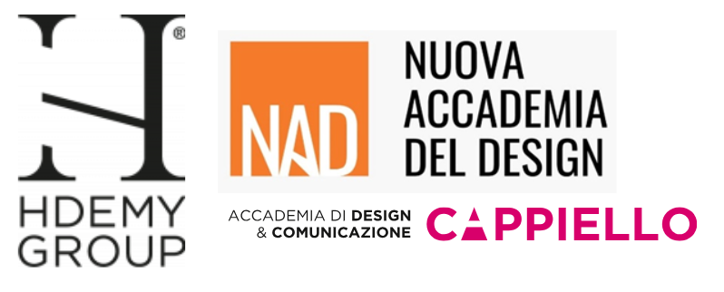
Hdemy Group
NAD – Nuova Accademia del Design
Accademia Cappiello

Hdemy Group was founded in 2012 as an educational hub specializing in the design, communication and marketing fields, with the aim of creating an educational ecosystem of excellence strongly connected with the business world. Thanks to many years of experience in academic training, the group is now positioned as a qualified interlocutor for companies, institutions and students, promoting educational paths that integrate theory, practice and the development of professional skills.

At its core, the group brings together two established and complementary entities:

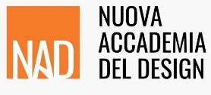
NAD – Nuova Accademia del Design
Founded in 2010, NAD - New Academy of Design represents the original core around which Hdemy Group has developed. Its educational proposal is based on a strong integration between creativity, practical application and constant updating of the skills required by the market. Thanks to a teaching staff composed of professionals active in their respective fields, NAD trains professionals capable of entering the world of work.
The educational offerings include one-year, two-year and three-year courses, professional and short courses, workshops and project activities in collaboration with companies and industry partners. The "learning by doing" approach characterizes the entire training model, encouraging experiential learning and the building of operational skills.

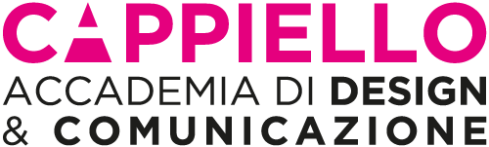

Accademia Cappiello
In 2024, Hdemy Group expanded its educational project with the acquisition of the Accademia Cappiello in Florence, a historic institution with over sixty years of experience in creative education. A nationally recognized point of reference, Accademia Cappiello enriches the group's offer by bringing a consolidated tradition and strong specialization in areas such as graphics, visual communication, fashion and interior design.
The integration of Accademia Cappiello further consolidates Hdemy Group's mission: to train talents capable of responding competently and innovatively to the needs of the contemporary market, through quality educational paths that are constantly updated and strongly connected with the business world.

MISSIONS AND VALUES

Mission
NAD – Nuova Accademia del Design’s mission is to offer comprehensive and specialized training courses aimed at young people, professionals and companies, with the goal of accompanying them in their professional growth and affirmation in the world of design. The Academy constantly integrates the evolution of business and technology, paying special attention to innovative processes and the dynamics of the contemporary market.

Core values
- Innovation
Teaching integrates advanced digital tools, artificial intelligence and new technologies, training professionals ready to face future challenges with an experimental and dynamic approach, always up-to-date regarding to the evolution of the field.
- Excellence
Highly qualified lecturers, practice-oriented training method and solid connections with the world of work ensure a concrete learning path aimed at developing distinctive skills that are immediately spendable in the professional field.
- Sustainability
The educational offerings promote responsible design, attentive to the use of innovative materials, sustainable processes and reduced environmental impact, in line with the needs of a market increasingly oriented toward social and environmental responsibility.
- Inclusivity
The Academy valorizes diversity as a lever of creativity and innovation, offering an open, dynamic and accessible environment where any talent can express itself, grow and actively contribute to cultural and design dialogue.

TEACHING COURSE
NAD's teaching staff is composed of professionals active in their respective fields of specialization, with consolidated operational and design experience. The “learning by doing” training model, enriched by the constant comparison with partner companies and design studios, allows students to develop concrete and always up-to-date skills, encouraging a conscious and competitive entry into the world of work.

The teaching environment stimulates individual and collective growth, encouraging discussion, exchange of ideas and continuous innovation, in an academic context attentive to the quality of training and services offered.

CERTIFICATIONS AND RECOGNITIONS
Over the years, the New Design Academy has obtained important awards, consolidating its position of excellence in design and communication training.

- - ISO 9001:2015 Certification
Issued by Transpacific Certification Limited, it attests to the adoption of a Quality Management System that complies with international standards, guaranteeing the consistent quality of the training services provided.
- CEPAS Bureau Veritas certification for the Interior Design course
The course is recognized as a comprehensive pathway for the acquisition of the skills required in the role of Interior Designer, with international validation.
- Certiport Authorized Center - Thesis Automation
NAD is authorized to issue globally recognized professional certifications for Adobe and Autodesk software.
- IQC Digital Badge Certifications
The Academy offers the possibility of obtaining Digital Badges, which represent and certify the skills acquired by students through two types:
  - or Open Badges: they certify the completion of courses, projects or training activities.
  - or Competence Badges: they certify specific skills and document, in detail, the skills and evidence of learning achieved.
- EABHES International Accreditation
NAD - Nuova Accademia del Design has started the EABHES (European Accreditation Board of Higher Education Schools) accreditation procedure, an international body that allows for the recognition of ECTS (European Credit Transfer System) training credits equivalent to CFUs in the Italian university system.
Upon completion of the procedure, the three-year pathways will allow students to obtain 180 ECTS and earn the Bachelor’s degree, with full European and international expendability.

THE TRAINING OFFER
NAD - Nuova Accademia del Design training offer is structured to meet the needs of a constantly evolving market, with highly specialized paths oriented to the development of immediately applicable professional skills. Teaching combines a theoretical approach with a strong practical component, encouraging experiential learning through workshops, project work and collaborations with partner companies.

Pathways offered include:
- One year, two-year and three-year courses
Medium- and long-term programs designed to provide comprehensive preparation in the various design disciplines.
- Professional courses and short programs
Intensive courses dedicated to professionals and students who wish to update or enhance their skills in a short period of time.
- Workshop and project work
- Practical activities carried out in collaboration with companies, design studios and industry realities, allowing students to confront themselves with concrete projects.
- Seminars and masterclasses
Thematic meetings with experts, professionals and companies for in-depth study of specific topics and continuous updating.

The offer is divided into different disciplinary areas, including: Interior Design, Graphic and Visual Design, Fashion Design, Fashion Communication, Green Design, Brand Management, CGI & 3D Design, Digital Marketing and Communication.

NETWORK AND COLLABORATIONS
NAD promotes constant interaction with the business and professional fabric through a wide network of companies, design studios, communication agencies and cultural institutions, which actively participate in educational activities, special projects and events promoted by the academy.
Active collaborations enable students to:
- Confront real projects and company case histories
- Participate in project work commissioned by partner companies
- Undertake career guidance and job placement paths
- Build an initial network of relationships with the working world

SOME NUMBERS
- More than 15 years of experience in specialized training in design
- More than 100 professors and professionals active in their own sectors
- More than 30 active training tracks including one-year, two-year, three-year and vocational courses
- A network of more than 150 companies and partners involved in training projects and institutional events
- More than 3,500 students trained over the years

NAD – Nuova Accademia del Design
Via Santa Teresa 2 – 37135 Verona (VR)
accademiadeldesign.com
info@hdemygroup.com
+39 045 58 24 48

For press inquiries and personalized interviews:

OGS PR & COMMUNICATION
Via Francesco Koristka 3 - 20154 Milano (MI)
www.ogscommunication.com - press.ogscommunication.com
info@ogscommunication.com
+39 02 34 50610

