
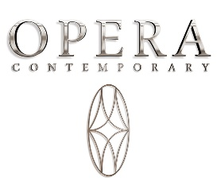

Angelo Cappellini and the Opera Contemporary brand present their collections during the Milano Design Week, in a location at the heart of the city, at the renowned venue “Il Salumaio di Montenapoleone,” hosted in the historic Bagatti Valsecchi palace.

On the occasion of MDW 2025, Opera Contemporary introduces the new book “HERITAGE COLLECTIONS,” which tells a journey through creativity and innovation from the very beginning, a tribute to the collections that have defined the identity of Opera Contemporary and embodied the values of authentic and timeless luxury.

ANGELO CAPPELLINI
The Angelo Cappellini space is divided into two areas: a front box at the entrance and a corner, both featuring floral-patterned wallpaper.

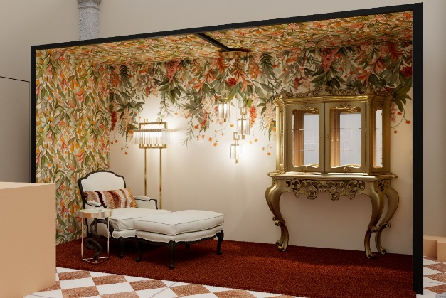
Figura 1 - Angelo Cappellini_front box

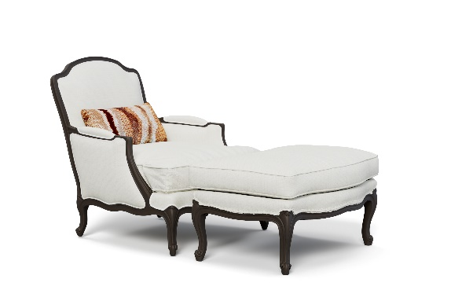
Figura 2 – Angelo Cappellini_ armchair in Louis XV style + Pouf

Inside the first box space, Angelo Cappellini presents the armchair model 8865 in Louis XV style, accompanied by its pouf, simulating the possibility of becoming a chaise longue. The armchair and pouf are finished in black lacquer with champagne gold details, featuring white bouclé fabric and dark profiles.

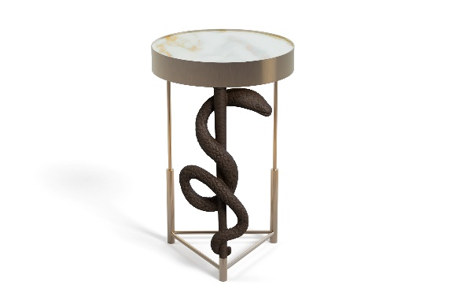
Figura 3 - Angelo Cappellini_Cobra coffee table

The Cobra coffee table is another product featured, with a structure in brushed brass metal, housing a hand-carved cobra figure at its center, finished in black lacquer with champagne gold details, in harmony with the armchair. The Calacatta Oro marble top enhances any space with a touch of refined originality.

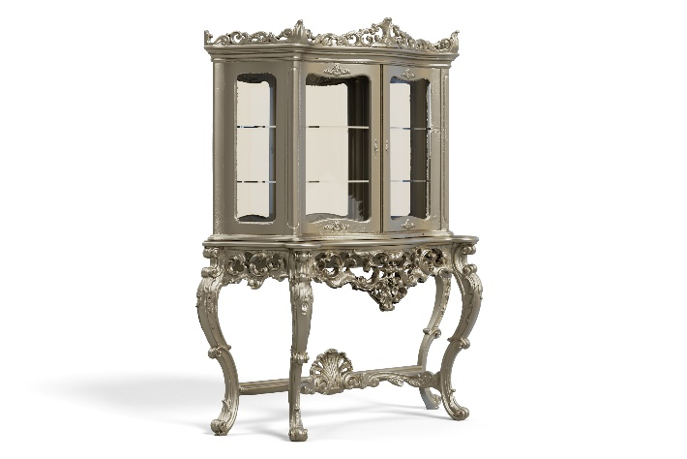
Figura 4 - Angelo Cappellini_ Baroque-style cabinet
The Baroque-style cabinet, finished in silver leaf with gold patina on a black background, features a finely hand-carved base and an upper section with glass-fronted doors and shelves. The interior includes a mirrored back panel, with spotlights positioned to illuminate the objects displayed inside.

From the collaboration with MASIERO, there is a composition of pendant lamps and a floor lamp from the CREK collection.

From the collaboration with LUCONI, the CHAMELEON collection is showcased, featuring glass/aluminum doors and partition walls.

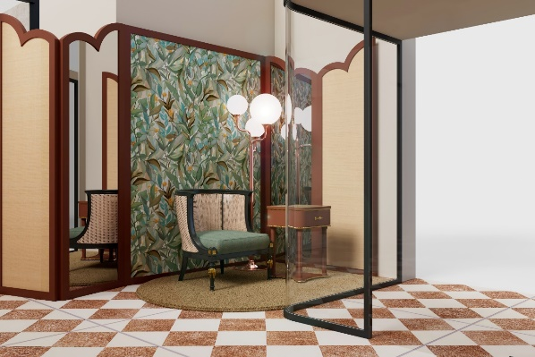
Figura 5 - Angelo Cappellini_corner

To the right of the entrance, there is the corner featuring a screen that serves as a backdrop, with floral wallpaper.

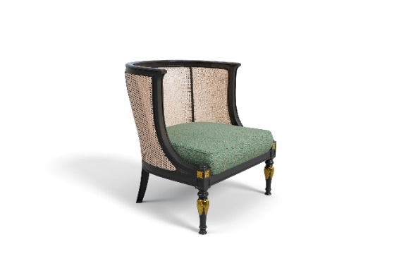
Figura 6 - Angelo Cappellini_ armchair in Louis XVI style

The corner showcases the new armchair model 7610/A in Louis XVI style, characterized by a natural Vienna straw backrest, with a black lacquered, aged structure and antique gold details. The seating cushion is upholstered in bouclé fabric, in shades of green.

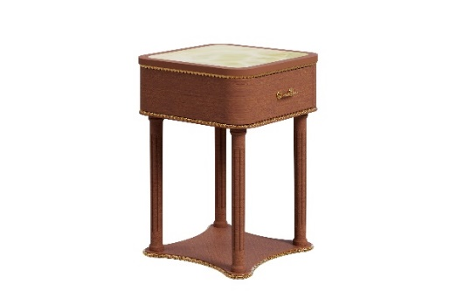
Figura 7 - Angelo Cappellini_ drawer/side table model 37601 in Louis XVI style

Next to the armchair is the nightstand with drawer/side table model 37601 in Louis XVI style, featuring a structure made of burl veneer on the base, finished in Tinto walnut with antique gold accents. The inset top is made of fine Pakistani onyx marble, which echoes the green tones, complementing the armchair.

From the collaboration with MASIERO, there is a floor lamp from the TEE collection.

OPERA CONTEMPORARY

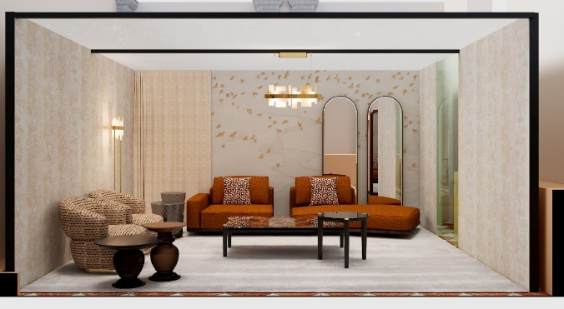
Figura 8 - Opera Contemporary_living area

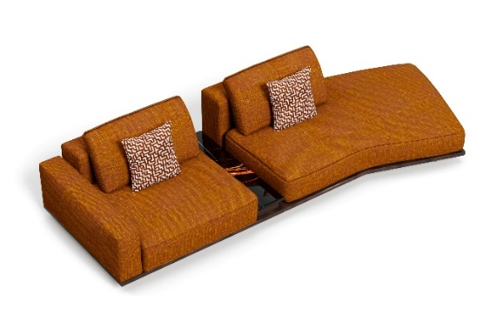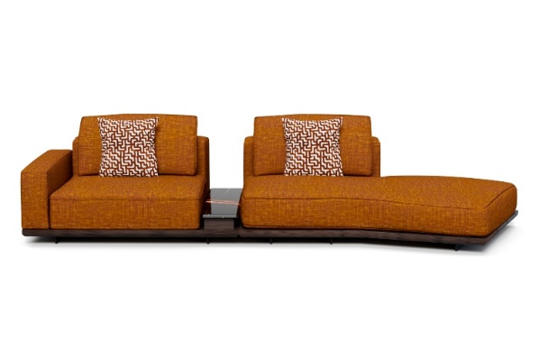
Figura 9 - Opera Contemporary_Normand modular sofa

The Opera Contemporary space furnishes a living area that features the new Normand modular sofa with modern lines. The sofa has a padded structure, with back cushions that rest folded on the upper part of the sofa, covered in camel-colored fabric. A solid wood base frame, finished in wenge, encloses the lower section, elevated from the ground by sturdy metal feet.
The Normand sofa is presented in a two-module composition: the left side features a single terminal with an armrest on one side, while on the other side, there is a low service table with a Sahara Noir marble top, black with veining that complements the fabric of the sofa.
The right module of Normand is a terminal with a pouf, angled at the corner, completing the composition and adding movement to the living area.

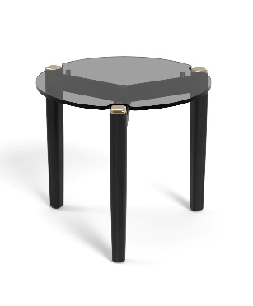

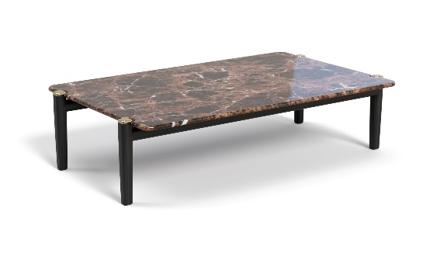

Figura 10 - Opera Contemporary_Thierry coffee table_with Emperador Dark marble top

Figura 11 - Opera Contemporary_Thierry coffee table_with bronzed glass top

In the center of the living area, two coffee tables from the Thierry collection are placed. Their solid ash wood structure is enhanced with golden metal tips on the tops of the legs, which reach the same height as the tabletop and outline its perimeter, following its undulating shape.
Available in different heights, the central coffee table features an Emperador Dark marble top, while the taller side table is made of bronzed glass.

An important new feature is the possibility of creating the coffee tables in blown Murano glass, thus enhancing the materials available for the collection.
Figura 12 - Opera Contemporary_Vertex coffee table

The coffee tables from the Vertex collection embody the elegance of nature in an essential and refined form. Made of bronzed blown glass, each piece stands out for its unique "Balloton" texture, creating a play of reflections that emerges under a light source, giving a precious and sophisticated aura to the space.
The solid ash wood legs, finished in wenge, with their warm and bold character, embrace the structure with natural grace, while the metal plate at the base adds a touch of brightness, enhancing the entire composition.

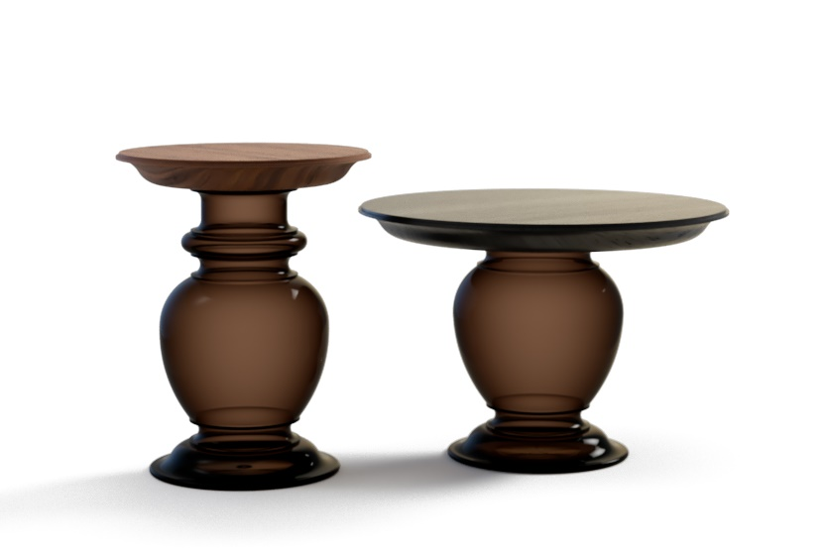
Figura 13 - Opera Contemporary_Oleas coffee table

The Oleas coffee table collection represents a timeless icon reinterpreted to express a new vision of elegance and modernity. In this unique version, the Oleas tables captivate with a base made of bronzed blown glass, expertly handcrafted, offering shimmering reflections and a sense of sculptural lightness. This ethereal transparency blends seamlessly with the natural solidity of the solid wood top, available in two precious wood types: ash and canaletto walnut.

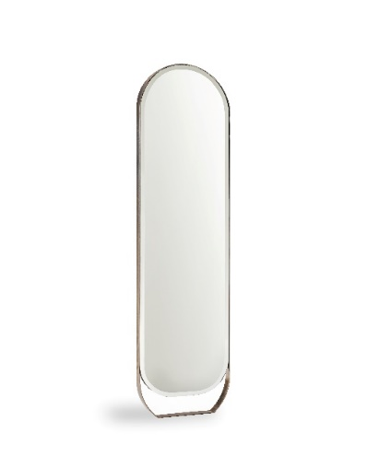
Figura 14 - Opera Contemporary_Label mirrors

The final new addition on display is the Label mirrors, featuring a narrow and elongated metal frame with a rounded top, finished in brushed brass. They are placed in pairs against the background of the space to add depth to the environment.
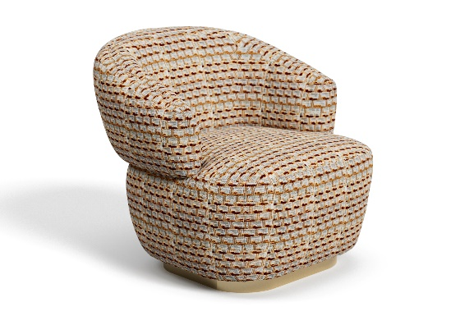
Figura 15 - Opera Contemporary_Sophie armchairs

The space also features two Sophie armchairs, in the best-selling swivel version of the collection, which makes them extremely versatile. The 360° rotation is perfectly integrated into the base, and thanks to its high load capacity, the product can withstand considerable stress while providing unparalleled comfort.
The armchairs are upholstered in fabric with a geometric pattern in shades of white and camel, in harmony with the sofa. The base is finished in brushed brass.

From the collaboration with MASIERO, there is a pendant lamp and a floor lamp from the HONICÉ collection.

About Angelo Cappellini
Angelo Cappellini is the epitome of classic Italian furniture, a family history and tradition that has redefined the concept of elegance and craftsmanship in the world of interior design. Today, the company stands on the international stage of both classic and contemporary design, with a solid experience and deep knowledge of the industry.

About Opera Contemporary
Since 2010, Opera Contemporary has been a benchmark in high-end furniture, blending artisanal tradition and contemporary design into a unique vision of luxury. The collections tell a story of stylistic research and tangible quality, intertwining authenticity, innovation, and versatility. The brand stands out for its ability to adapt elegantly to both the most exclusive residential environments and hospitality spaces, offering a proposal that celebrates attention to detail and manufacturing excellence.
Thanks to collaborations with internationally renowned designers, each creation becomes a perfect balance between aesthetics and functionality, designed to meet the needs of a sophisticated and cosmopolitan clientele.

OPERA CONTEPORARY - BRAND DI ANGELO CAPPELLINI & C S.R.L.
FACTORY & SHOWROOM Via B. Buozzi, 30
SEDE LEGALE Via Milano, 39
22060 - CABIATE (CO) - ITALY
angelocappellini.com
angelocappellini@acluxurygroup.com

OGS PUBLIC RELATIONS & COMMUNICATION
Via Koristka 3, 20154 Milano (Italy)
Ph. +39 023450610
www.ogscommunication.com – press.ogscommunication.com
@ogscommunication
info@ogscommunication.com

