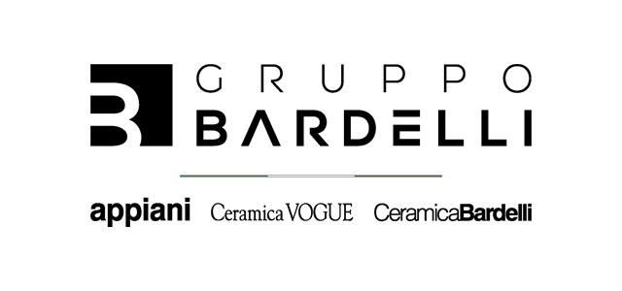
The Gruppo Bardelli at Coverings 2025: innovation and design in the new collections of Ceramica Bardelli, Ceramica Vogue and Appiani
The Gruppo Bardelli will be a part of Coverings 2025, the most significant international event dedicated to the ceramic surfaces sector, which will be held from April 29 to May 2 in Orlando, USA. For this occasion, the Group will present three new cutting-edge collections designed to meet the needs of all types of environments with a mix of innovation, aesthetics and quality craftsmanship.
Ceramica Bardelli presents Segmenti a new collection of 5x20 cm listels that harmoniously combines craftsmanship and innovation.
The collection is developed through three distinctive interpretations - Ceramica, Naturae and Compatta - each characterized by unique textures and a carefully curated color palette, ranging from white and gray-black to cool gray, terracotta, green and blue. Each piece is an expression of elegance and versatility, the result of a perfect balance of craftsmanship and advanced ceramic technology. Each variant tells a different story. Compatta is inspired by the solidity of concrete and stone, offering a compact and bold aesthetic. Naturae, on the other hand, captures the delicate essence of natural surfaces, creating a refined, slightly washed-out effect. Finally, Ceramica pays homage to the authenticity of the ceramic tradition, with pronounced edges that enhance depth and color intensity, evoking the charm of handcrafted ceramic objects.
With its perfect fusion of material and innovation, Segmenti is designed for contemporary interiors that seek sophistication without compromise. But this is just the beginning: the collection will continue to evolve, enriching itself with new inspirations drawn from the world of wood, marble, stone and other materials, once again confirming Ceramica Bardelli's role as a a reference in design ceramics.
Ceramica Bardelli launches Sinfonia
Ceramica Bardelli introduces Sinfonia, a collection with a strong aesthetic impact characterized by a craquelé base on frost-free porcelain stoneware, obtained through a special process in which the handcrafted glaze is subjected to fractures and then protected by an applied nanotech glaze protective fiber. Sinfonia is ideal for indoor environments and exterior wall cladding and is available in two sizes 20x20cm (8 “x8”) and 10x10cm (4”x4”) single piece or on 30x40cm (12 “x16”) mesh and in six refined and typical craquelé shades: white, green, turquoise, light blue, blue and cream. The result is an artisanal aesthetic recreated in an industrial key perfect for Mediterranean-style environments.
Sinfonia: a visual harmony where the tradition of craquelé meets contemporary design. Elegant formats, vibrant surfaces and a refined palette give life to spaces that sing of beauty and uniqueness.
Appiani presents Coriandoli
Appiani, a historic brand of the Gruppo Bardelli specializing in ceramic mosaic, presents Coriandoli, a new collection of hexagonal mosaics that echoes the proportions of the iconic Eden collection, available in 2.5x2.8 cm (2.5x2.8“ x 2.8”) sizes but with a reduced thickness of 4 or 4.5 mm making it lighter and more versatile. It can be mounted on 30x30 cm (12 “x12”) mesh. Coriandoli stands out for its extra-slim, square-edged shape and its palette of eight vibrant and intense colors capable of bringing warmth and dynamism to spaces. In addition, the collection introduces a new full-body technology ensuring greater material uniformity and resistance and stain Shield+ protection.
Coriandoli: an ultra-thin full body porcelain mosaic with unique colors that combine innovation and design.
With these three new proposals, the Gruppo Bardelli confirms its commitment to innovation in ceramic design with solutions that combine aesthetics, functionality and technological research.

For press inquiries and personalized interviews:

OGS PR and Communication
Via Koristka 3, Milano
www.ogscommunication.com – info@ogscommunication.com
press.ogscommunication.com
+39 02 3450610

